* CosmicWorks has big plans for their retail site, but they need to start somewhere; they need a landing zone in Azure for all of their services. It will take a while to prepare their e-Commerce site to migrate to Azure, but they're eager to launch a POC of a simple chat interface where users can interact with a virtual agent to find product and account information.
* They've created a simple Blazor web application for the UI elements and have asked you to to incorporate the backend plumbing to do the following:
* Store the chat history in an Azure Cosmos DB database
  + They expect the following types of messages: Session (for the chat session), Message (the user and assistant message).
  + A message should have a sender (Assistant or User), tokens (that indicates how many tokens were used), text (the text from the assistant or the user), rating (thumbs up or down) and vector (the vector embedding of the user's text).
* Source the customer and product data from the Azure Comos DB database.
* Use Azure OpenAI service to create vector embeddings and chat completions.
* Use a Azure Cognitive Search to search for relevant product and account information by the vector embeddings.
* Encapsulate the orchestration of interactions with OpenAI behind a back-end web service.
* Create a storage account to externalize prompts that will be used by your assistant.

**Objective :**

* Run the script to deploy the services into the landing zone in preparation for the launch of the POC.

## **Task 1: Register the required Resource providers**

1. Search for **Windows PowerShell** and run it as administrator

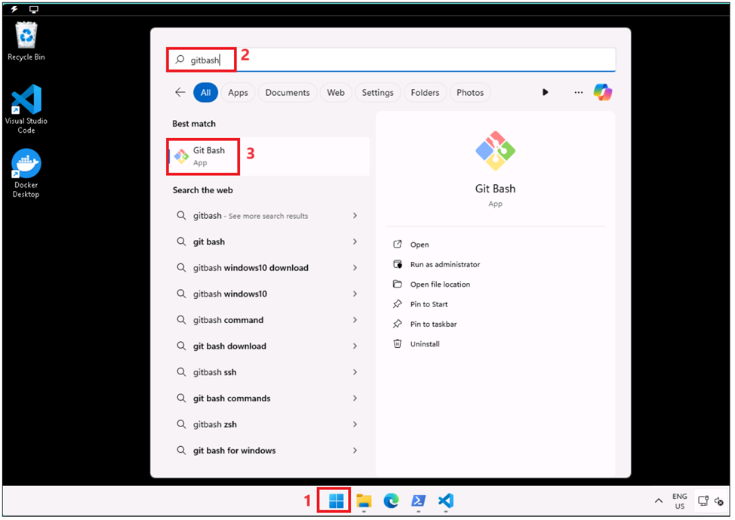

1. Run **+++az login+++** , it opens a default browser to sign in.

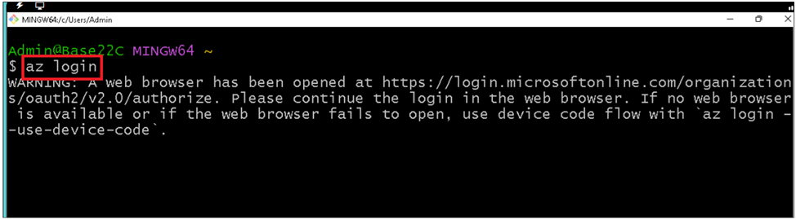

1. Sign in with your Azure subscription account.

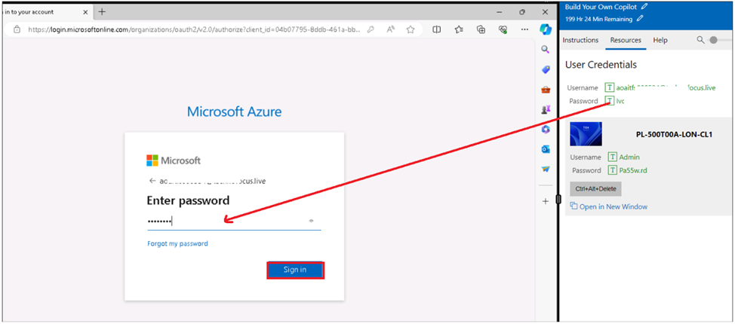

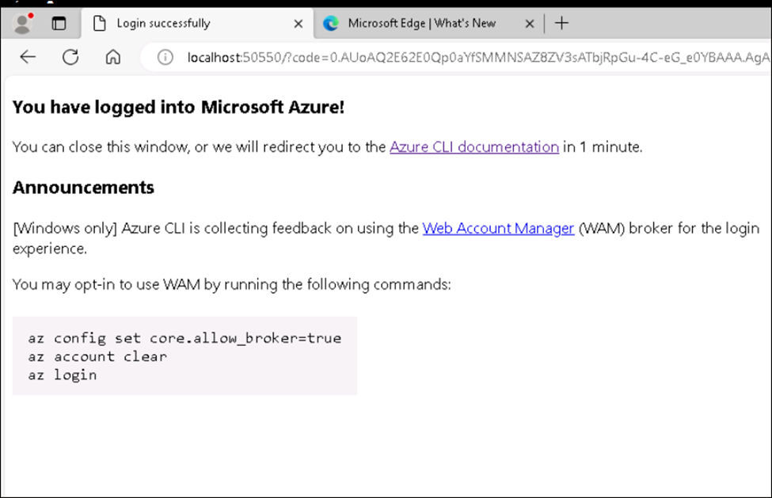

1. Switch back to **Gitbash** and **run** the below commands to register resource providers required to work on solutions.

az provider register --namespace 'Microsoft.Storage'  
 az provider register --namespace 'Microsoft.Security'  
 az provider register --namespace 'Microsoft.Search'  
 az provider register --namespace 'Microsoft.Sql'  
 az provider register --namespace 'Microsoft.Web'  
 az provider register --namespace 'Microsoft.ManagedIdentity'  
 az provider register --namespace 'Microsoft.DocumentDB'  
 az provider register --namespace 'Microsoft.Compute'  
 az provider register --namespace 'Microsoft.CognitiveServices'  
 az provider register --namespace 'Microsoft.ContainerRegistry'

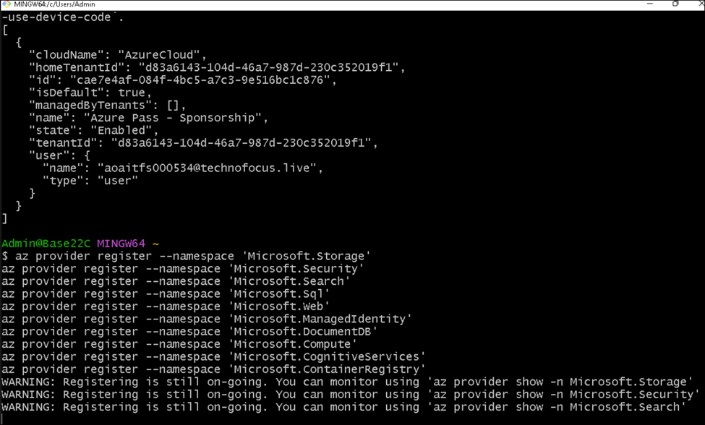

1. Registration of resource provides takes < 5min .You can continue with next task.

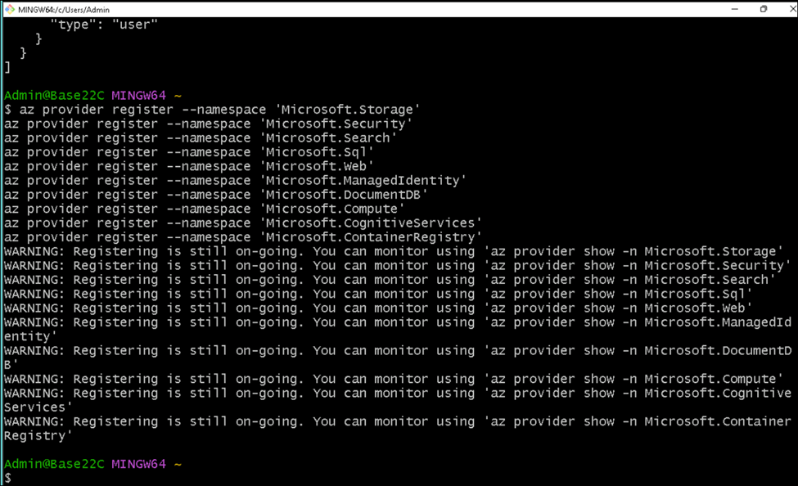

**Task 2: Deploy the Azure services needed to support the chat interface**

1. Open **Windows PowerShell** as **administrator** and run the below command to set the policy to **Unrestricted** and enter **A (Yes to All)** when asked to change the execution policy.

**Set-ExecutionPolicy Unrestricted**

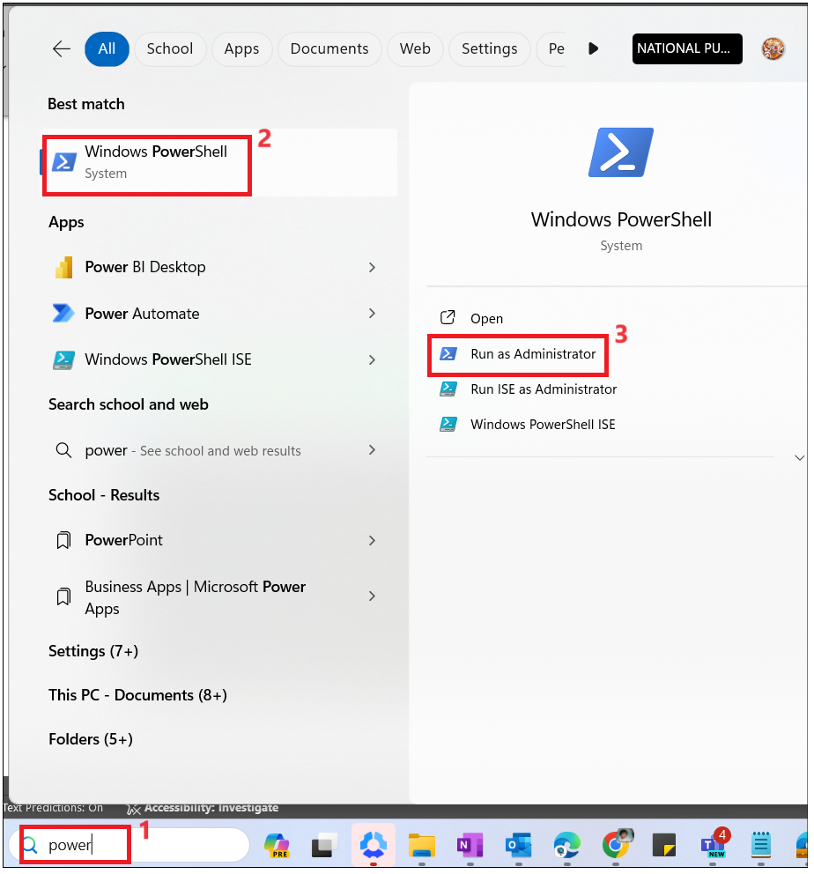

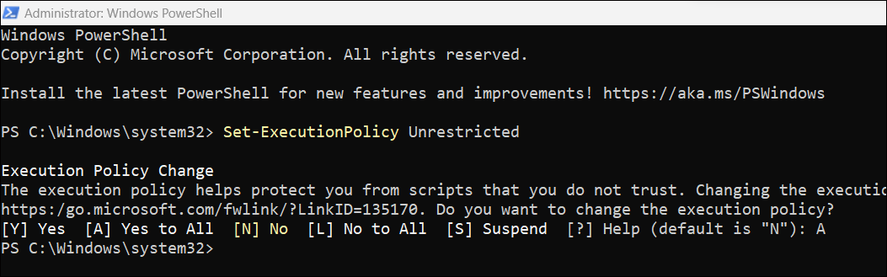

1. Navigate into the project starter-artifacts\code\VectorSearchAiAssistant folder by running the below command.

cd “C:\Labfiles\starter-artifacts\code\VectorSearchAiAssistant”

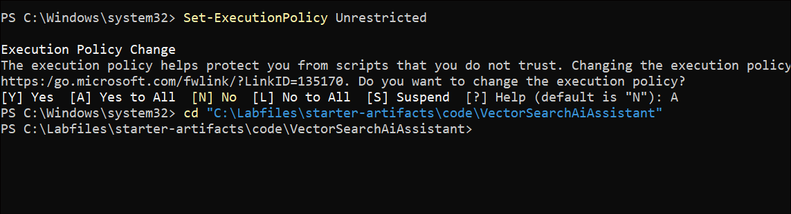

1. Run **az login** . it opens the default browser to sign into the Portal.

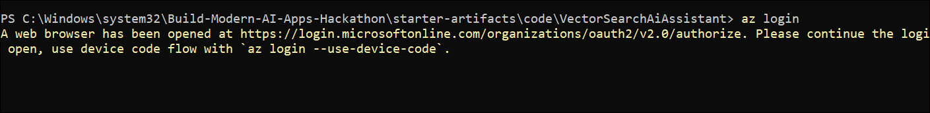

1. Sign in with your Azure subscription account.

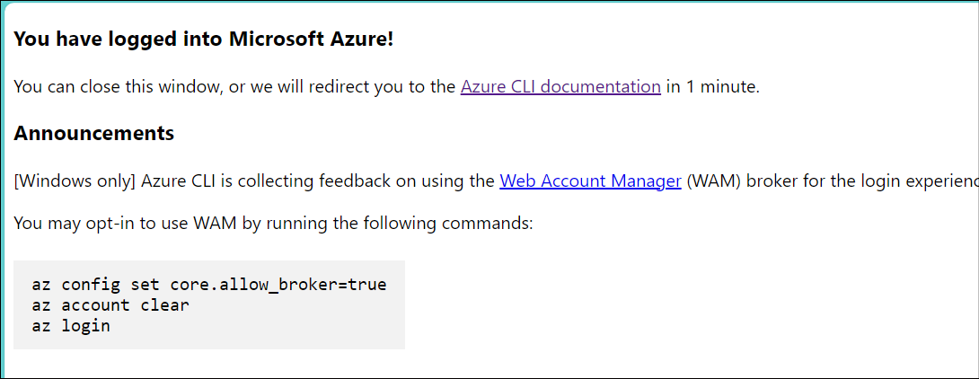

1. Switch back to the PowerShell window, you should see subscription details.

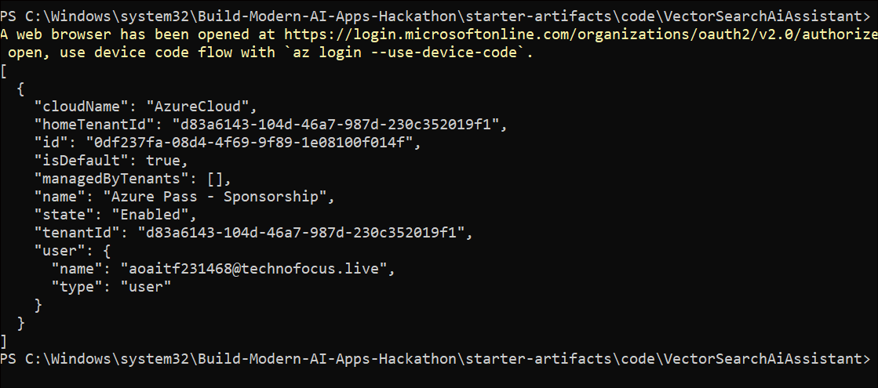

1. Run below command to generate unique resource group.

**$suffix = Get-Random -Maximum 1000**

**$resorucegroup= "cosmicworks_rg_" + $suffix**

**$suffix++**

**$resorucegroup**

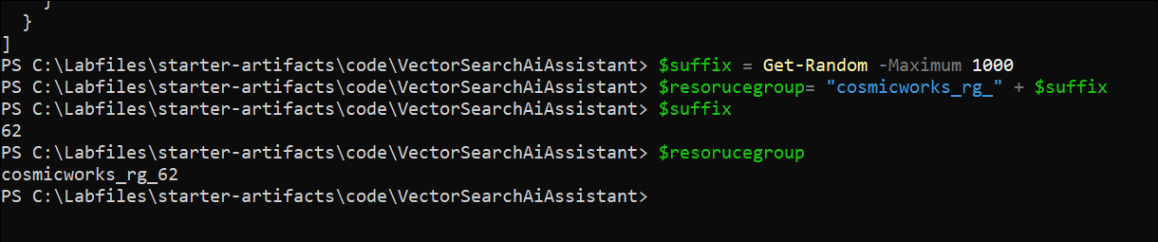

1. Run the following PowerShell script to provision the infrastructure and deploy the API and front end. This will provision all of the required infrastructure, deploy the API and web app services into Azure Kubernetes Service (AKS) if using the deploy Aks flag below or Azure Container Apps (ACA), and import data into Cosmos DB.
2. Update the subscription id with your subscription and run it.

./scripts/Starter-Deploy.ps1 -resourceGroup $resorucegroup -location eastus -subscription <subscription-id> -deployAks 1

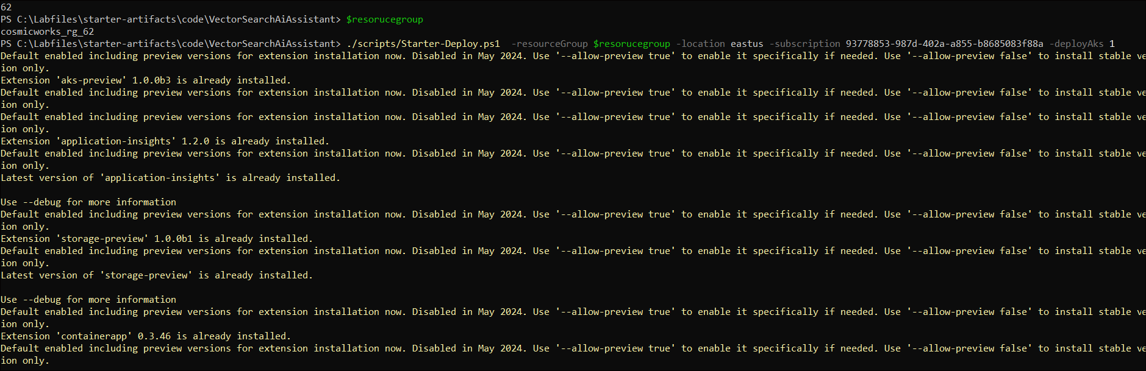

6. While running the script, the default browser opens to sign into the portal.

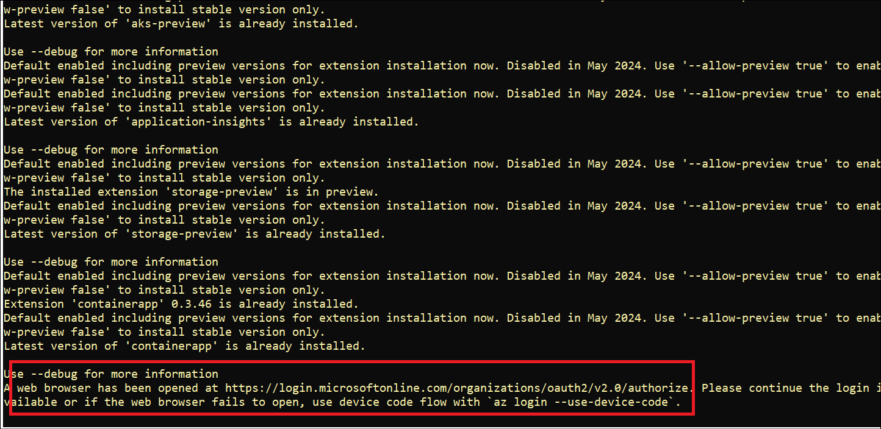

7. in the default browser, sign in with your Azure subscription account.

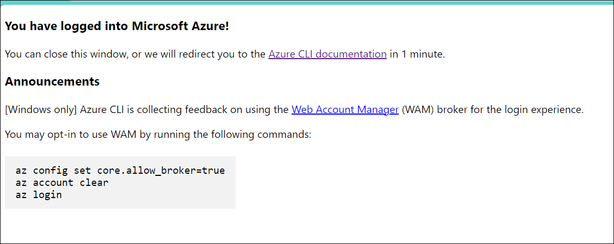

1. Wait for the ARM template to create a resource group in Azure Portal. ARM template will create a unique resource group for you.

**Note**: Ignore If you see ERROR: (ResourceGroupNotFound) Resource group 'cosmicworks_rg_XX' could not be found as the ARM template will create a resource group for you.

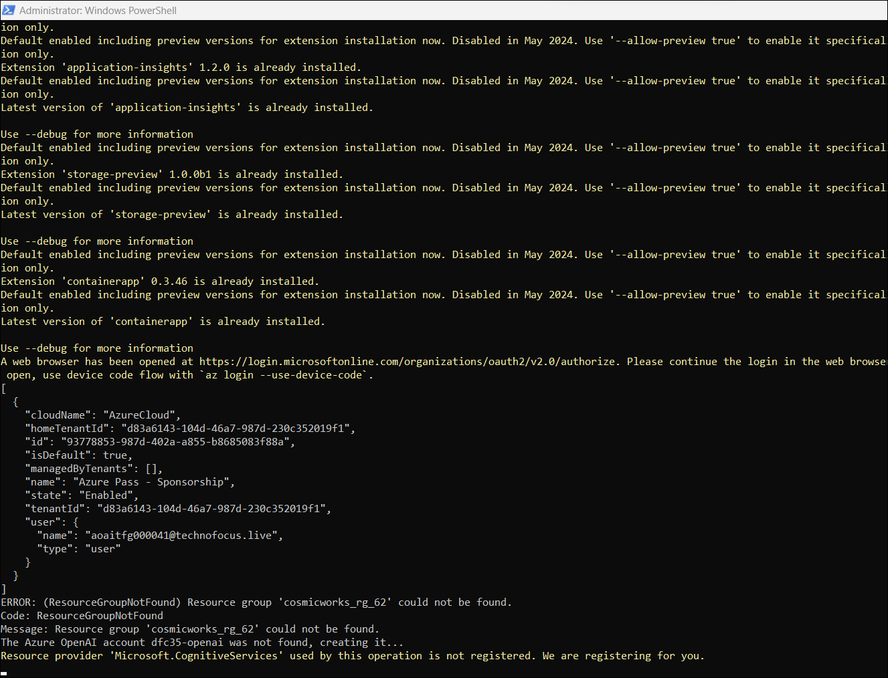

1. Wait for the ARM template to complete. It takes 10-15 minutes to complete.

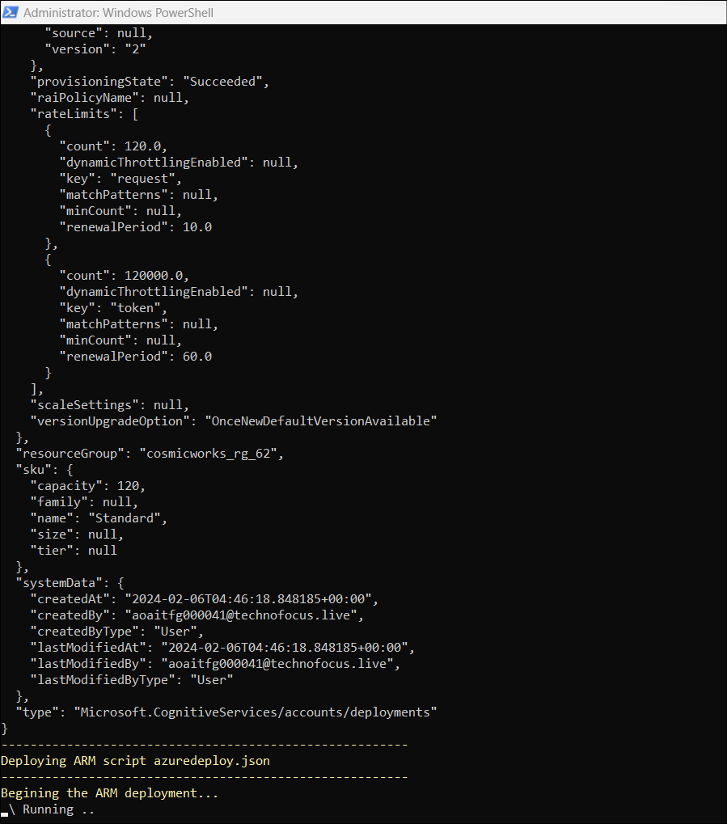

11.ARM template retrieving AKS name.

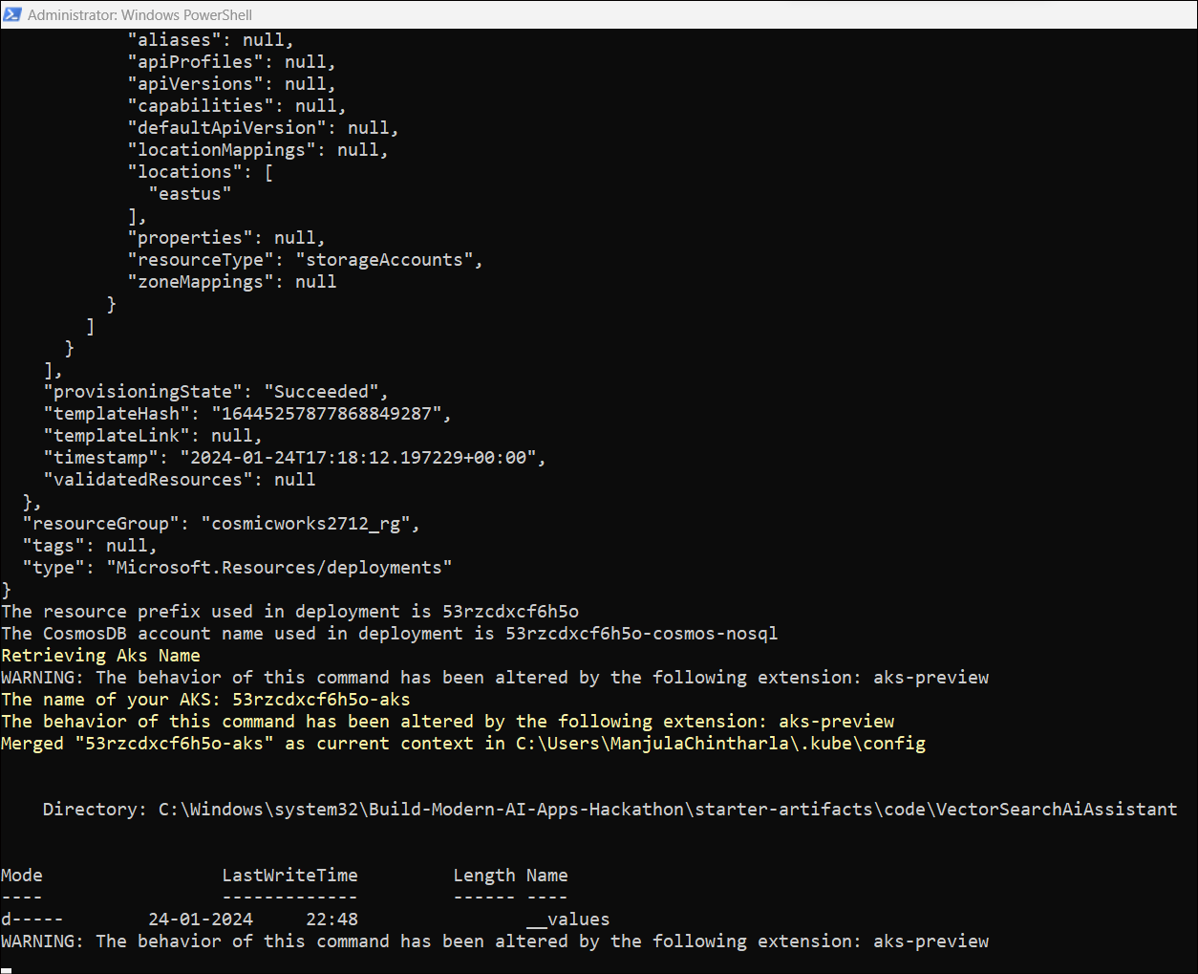

1. Save the below values in Notepad for further use.

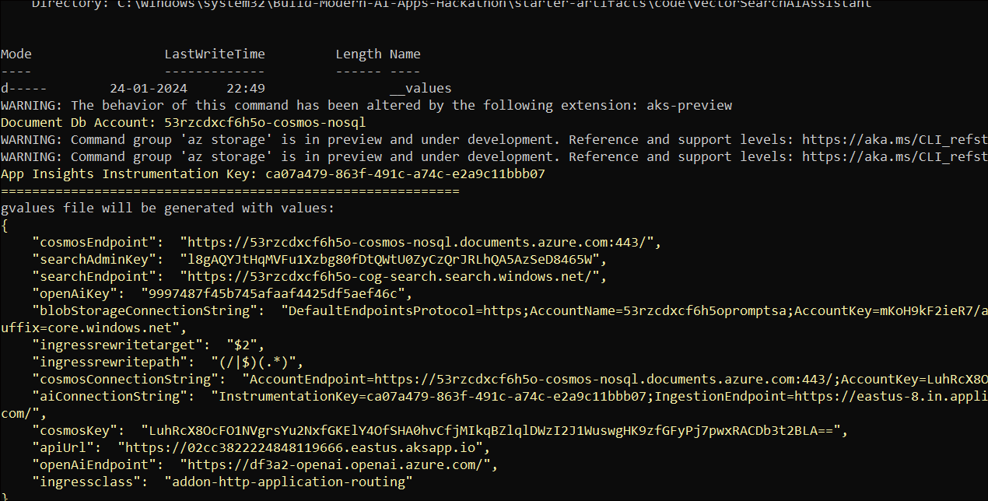

1. Files transferred completely and you can see the Final job status: Completed.

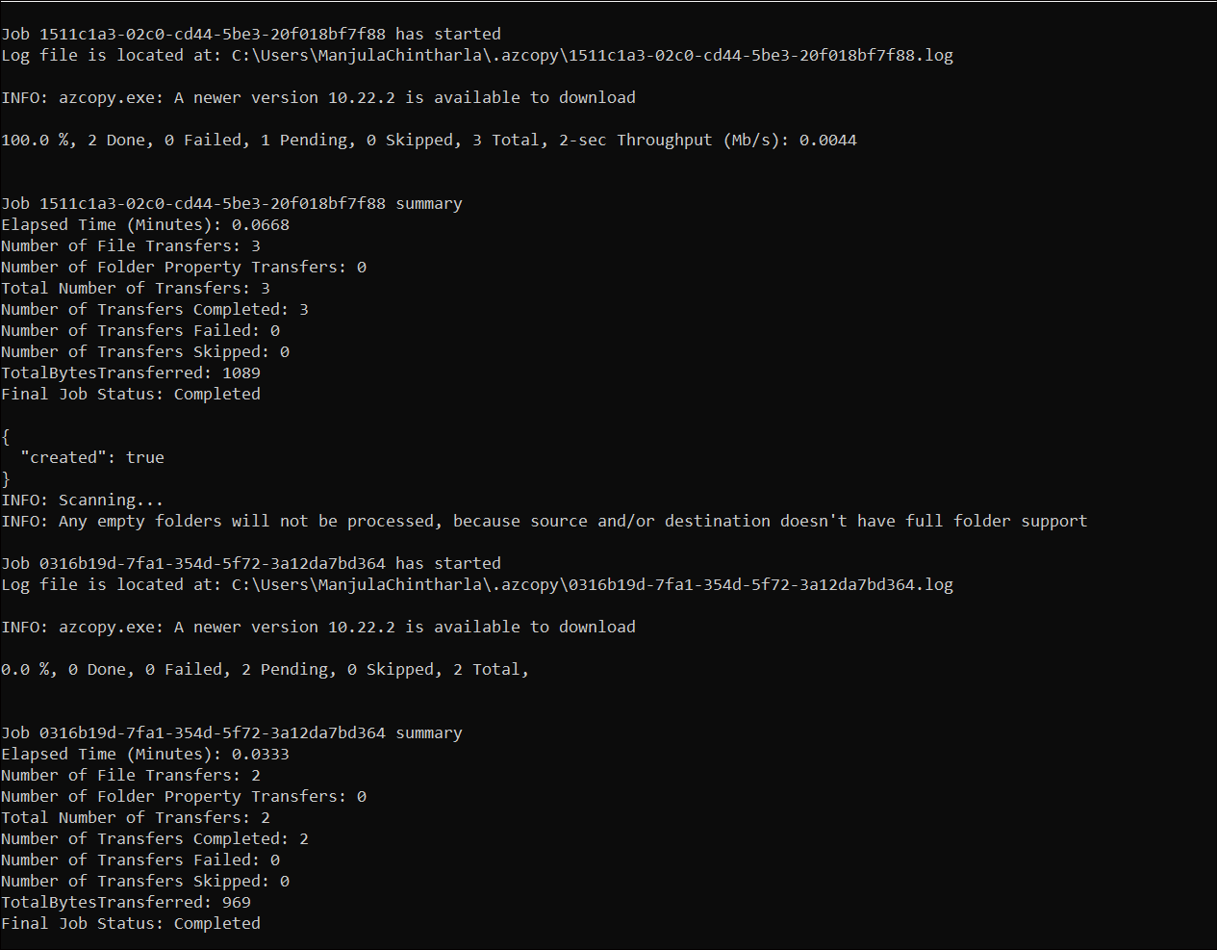

1. Deployment completed and front end hosted successfully. 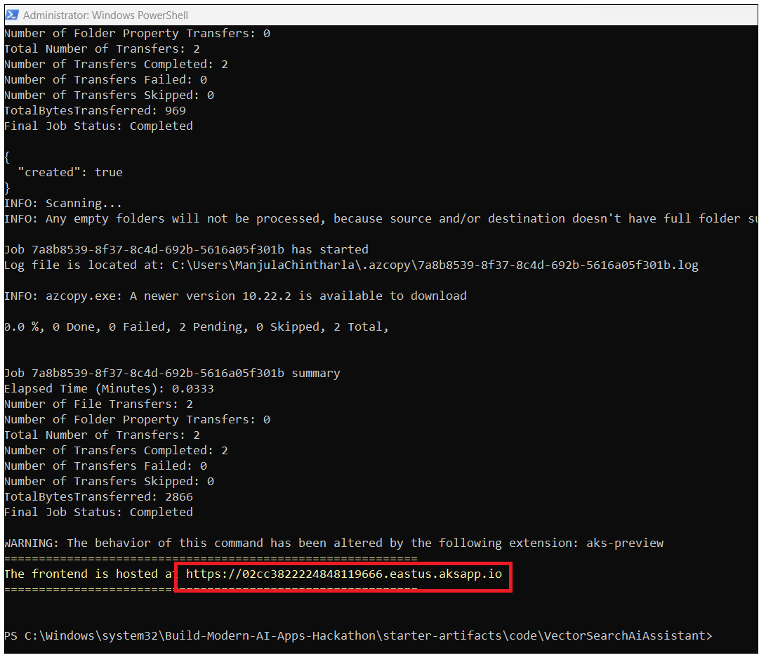
2. Browse to the website with the returned hostname.

If the website loads, you are ready to continue with the hackathon challenges. **Don't worry** if the website is not fully operational yet - you will get it there! .You can continue with next tasks.

**Task 3: Verify deployed resources in the Azure portal**

1. Open a browser go to <https://portal.azure.com> and sign in with your Azure subscription account.
2. On the Home page, click on **Resource Groups**.

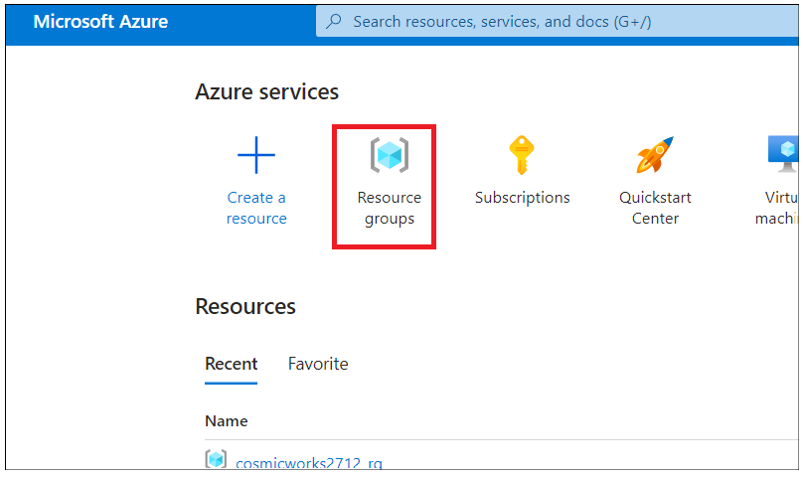

1. Click on your resource group name **cosminworks_rg_XXX**

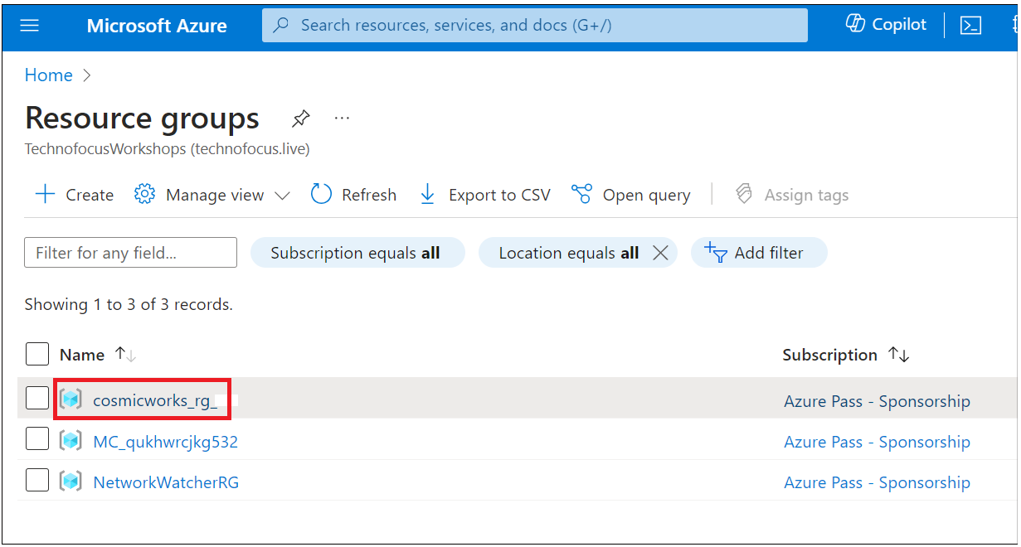

1. Make sure the below resource got deployed successfully.
   * Azure OpenAI Service
   * Azure Cosmos DB
   * Azure Cognitive Search
   * Azure Container Apps (or AKS)
   * Azure Storage
   * Azure Networking

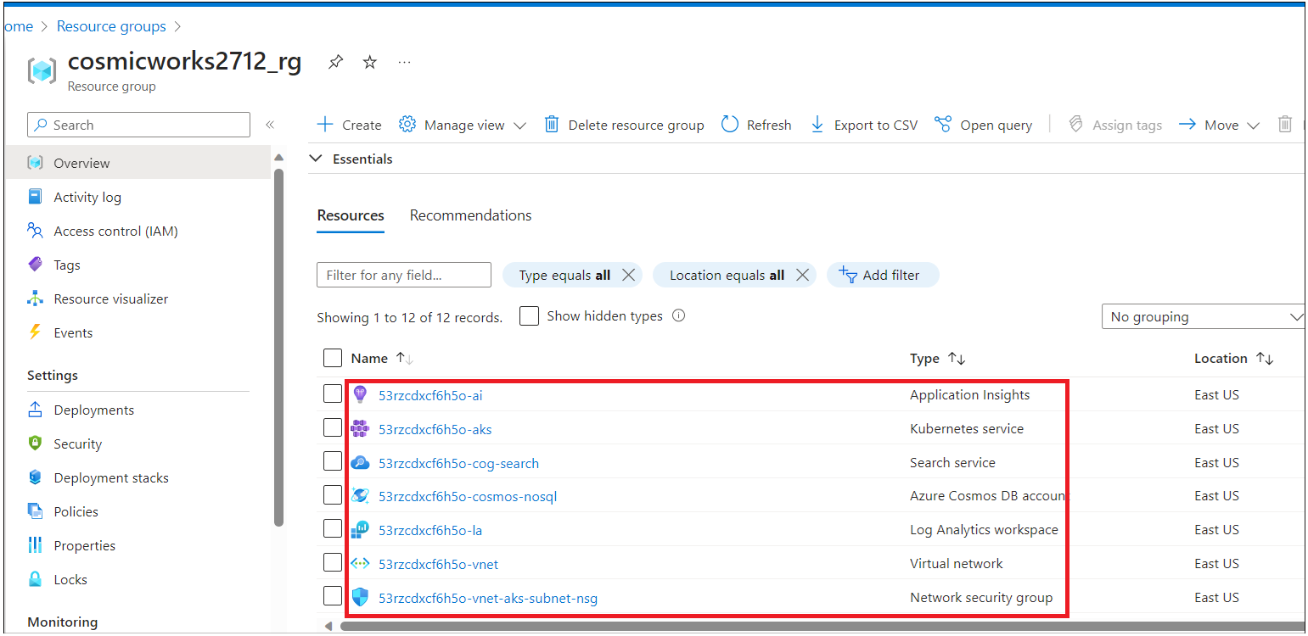

1. Make sure all the resources are deployed successfully. Copy the AKS name to use in the next step.

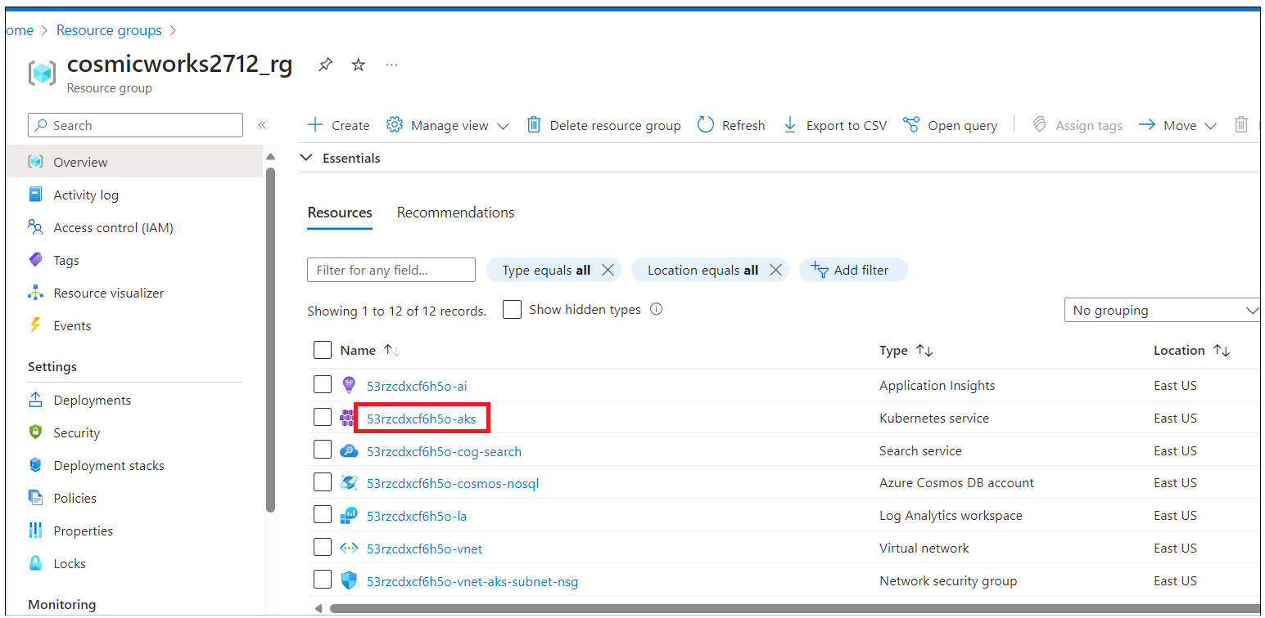

1. Switch back the PowerShell command line and execute the following command to obtain the website's endpoint:. Update below command with your aks name and then run it.

For AKS:

az aks show -n <aks-name> -g $resorucegroup -o tsv --query addonProfiles.httpApplicationRouting.config.HTTPApplicationRoutingZoneName



For ACA:

az deployment group show -g $resorucegroup -n cosmosdb-openai-azuredeploy -o json --query properties.outputs.webFqdn.value

1. Click on **Cosmos Account DB name**.

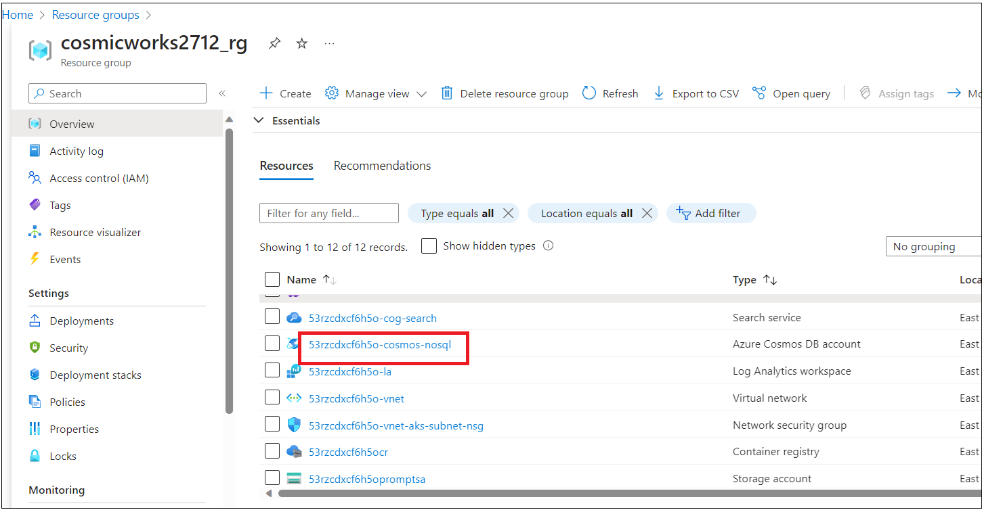

1. Click on **Keys** from the left navigation menu, copy URI value to a notepad as **Cosmos DB ENDPOINT** and key to a variable **Cosmos DB Key**.

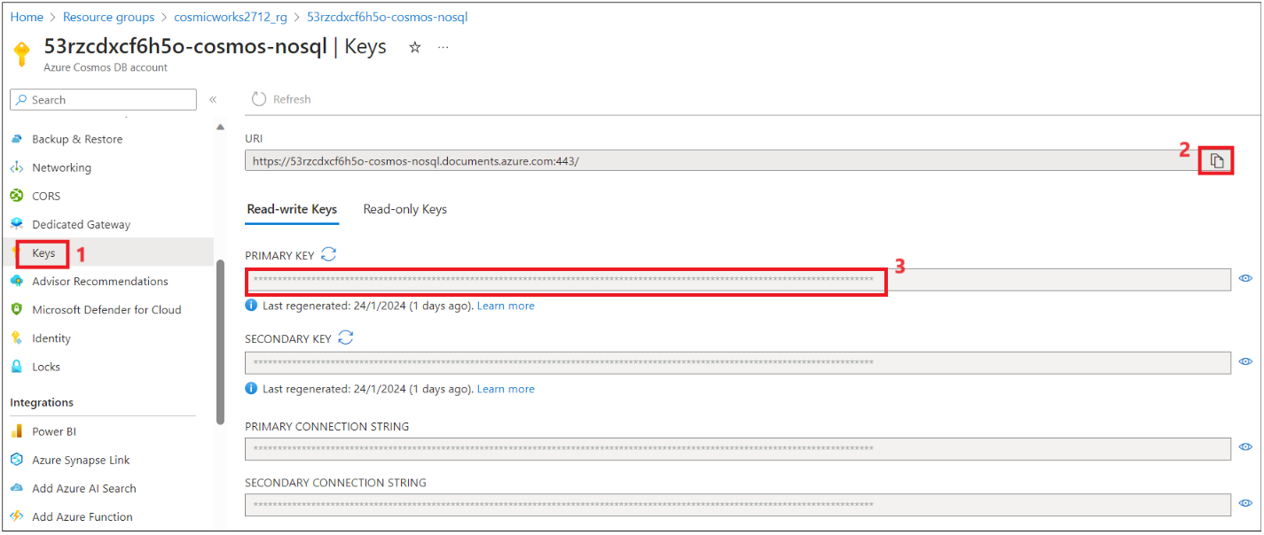

1. Click on **Data Explorer** and check that **database** and containers got created .

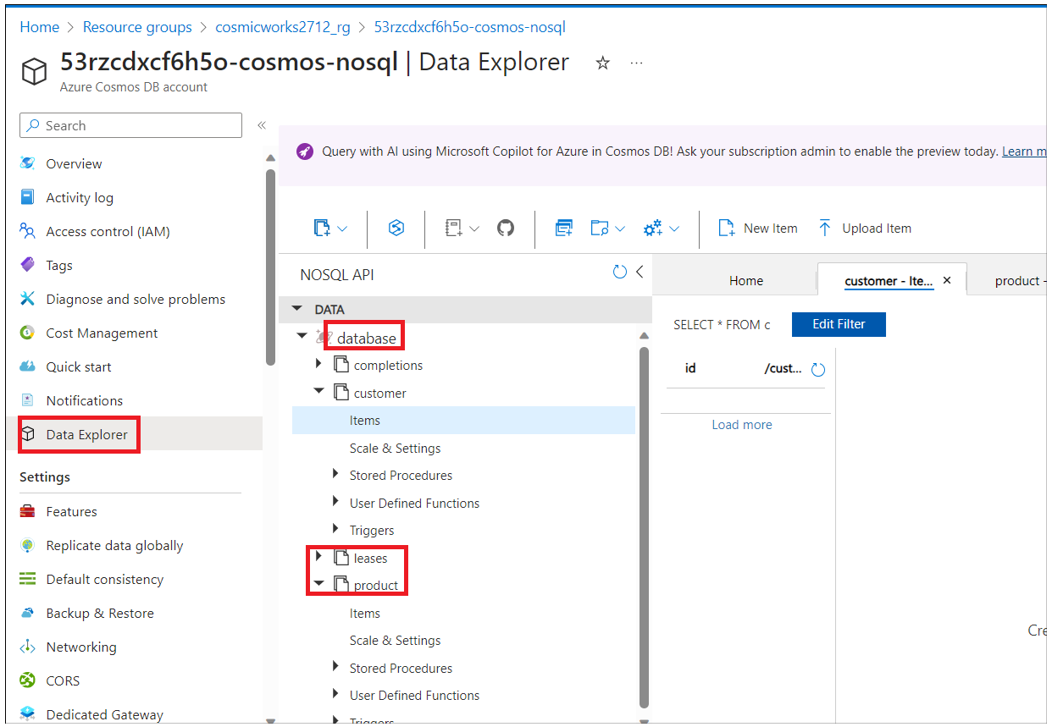

1. Go back to the resource group by clicking on resource group from the top navigation menu.

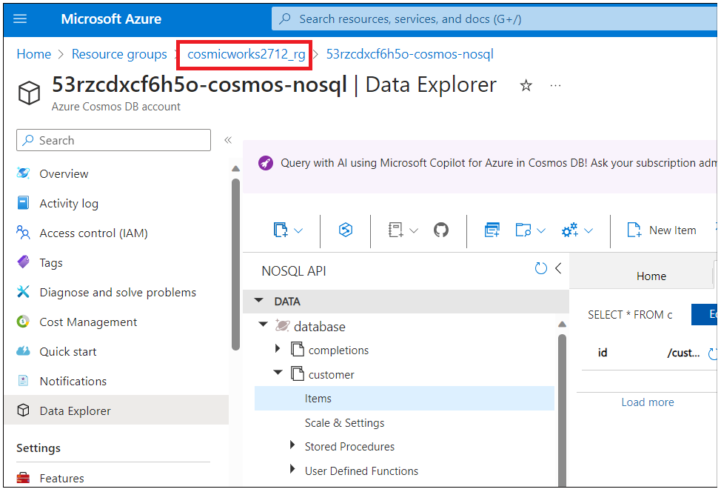

1. Make sure **Deploy Azure Container Apps**, **Azure Container Registry,** and **Azure Storage Account** are deployed successfully.

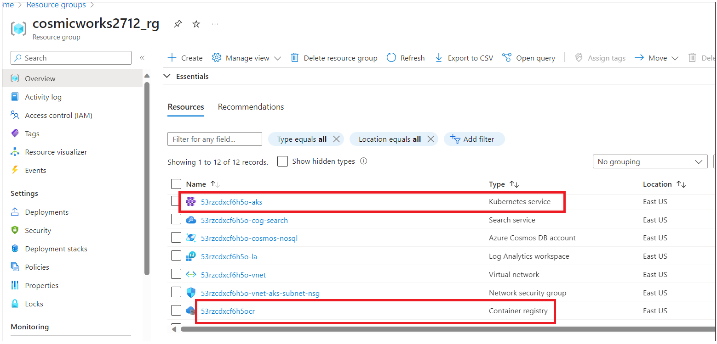

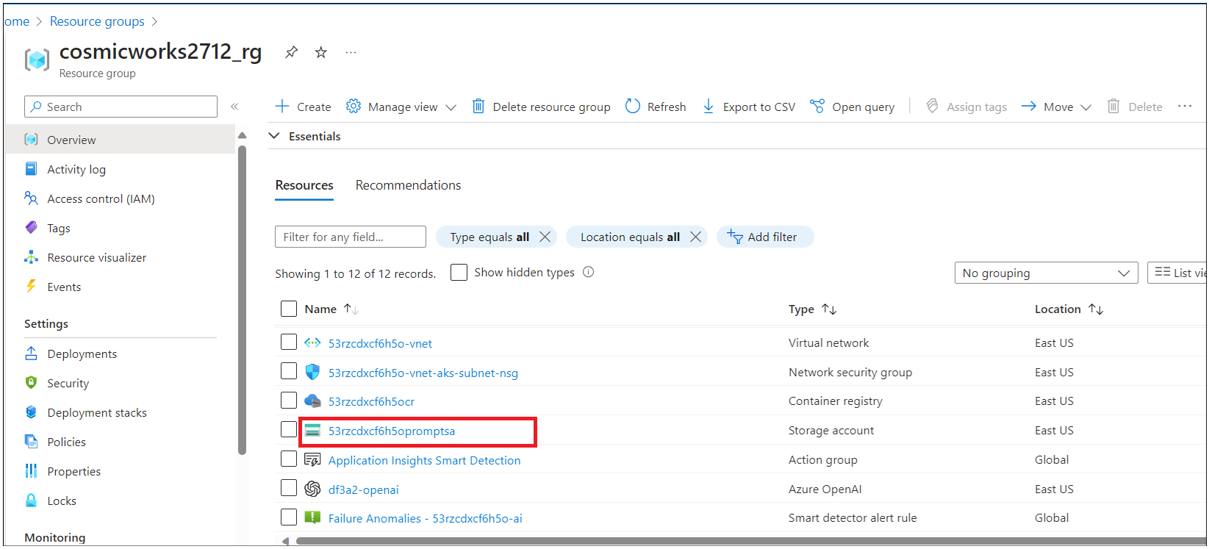

1. Go back to the resource group and click on **Azure Search** resource name.

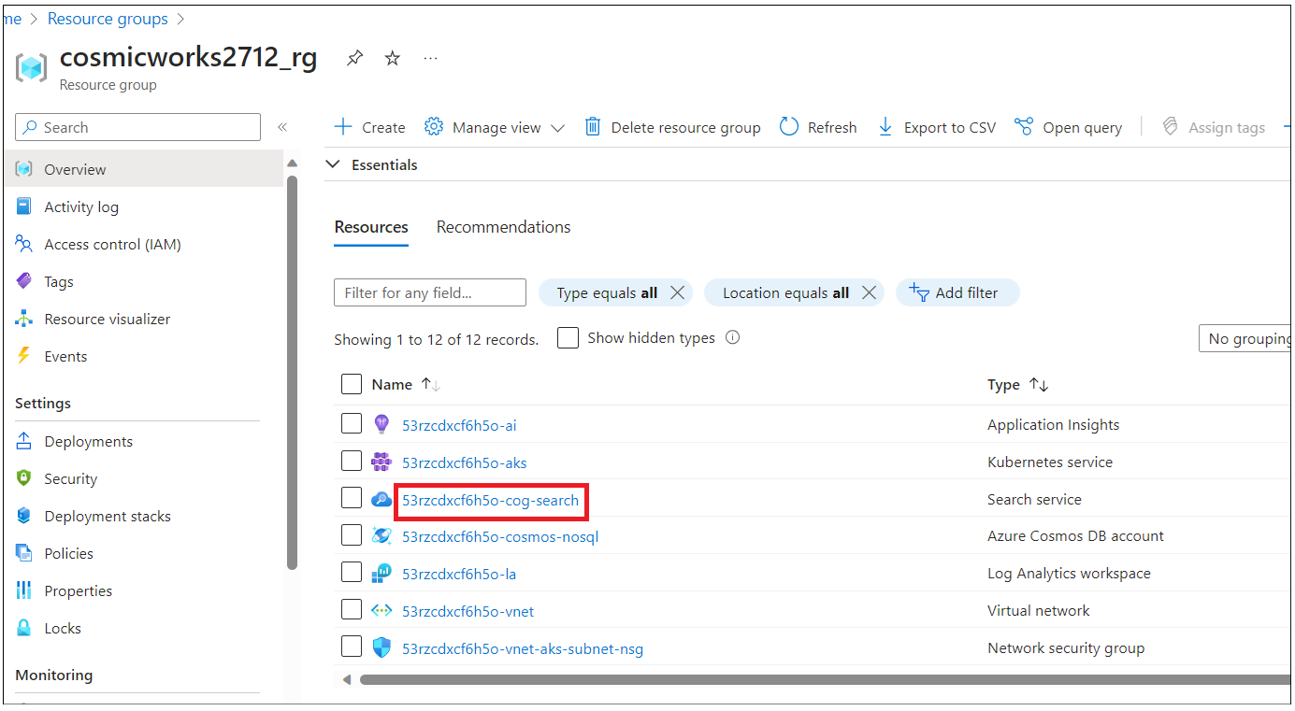

1. On the **Overview** page, copy URL to a notepad as **COGNITIVESearch ENDPOINT** to use in the next task.

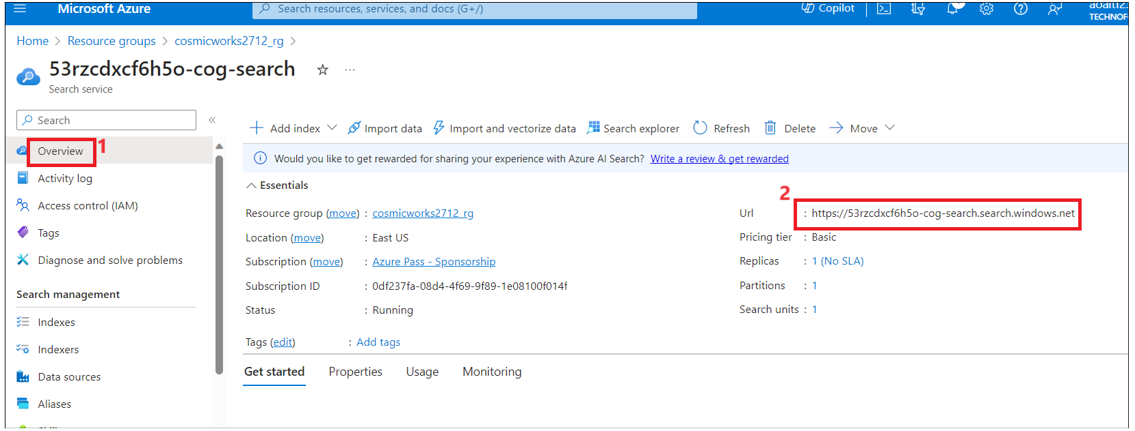

1. Click on **Key** under **Setting** from the left navigation menu and copy **Primary Admin Key** to a note pas as **COGNITIVESearch KEY**

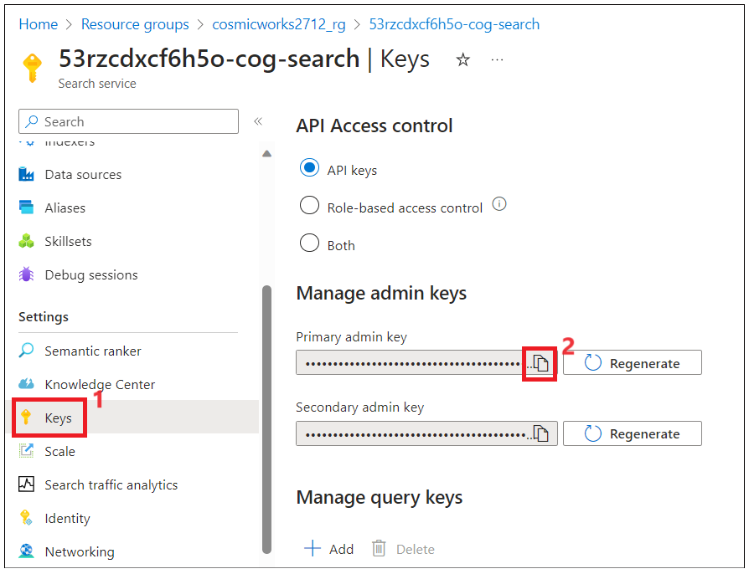

1. Switch back to resource group and click on **Azure OpenAI** resource name.

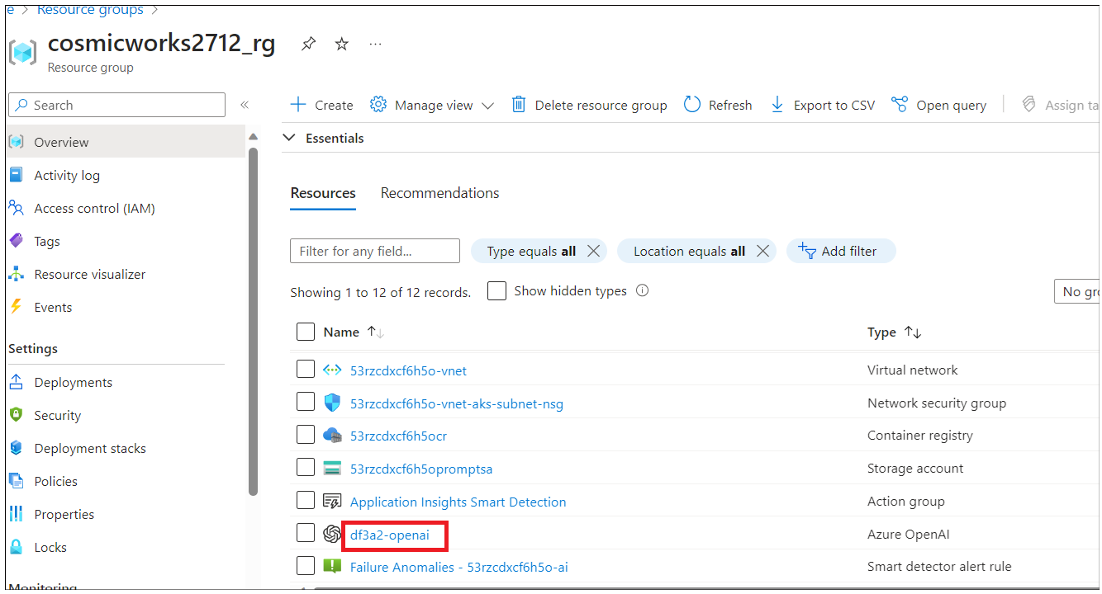

1. Click on Keys and Endpoints from the left navigation menu and then copy the endpoint value in a notepad to **AzureAI ENDPOINT** and key to a variable **AzureAIKey**.

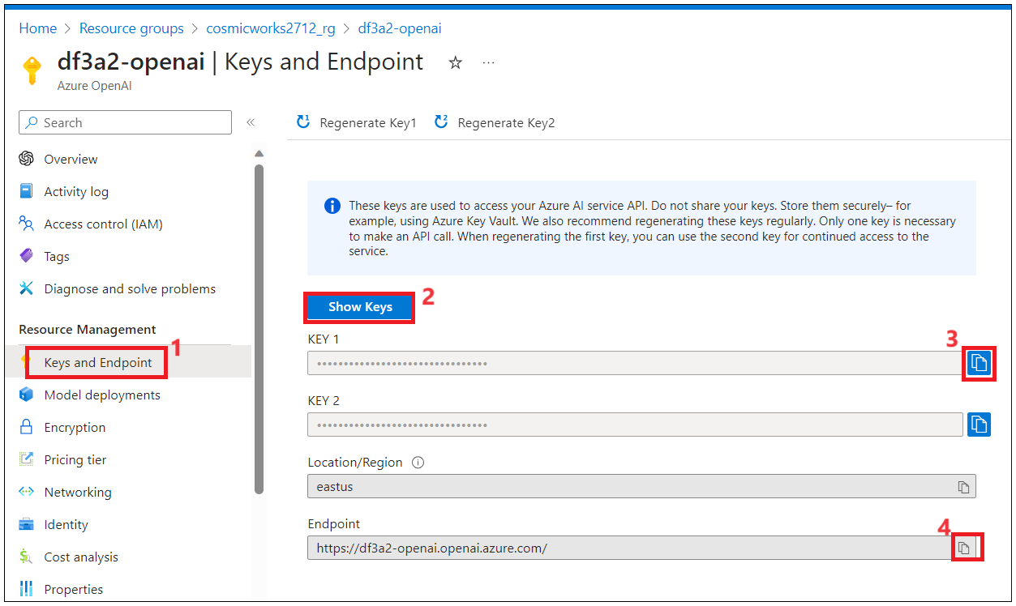

1. Right-click on **Go to Azure OpenAIStudio** and open it in a new tab.

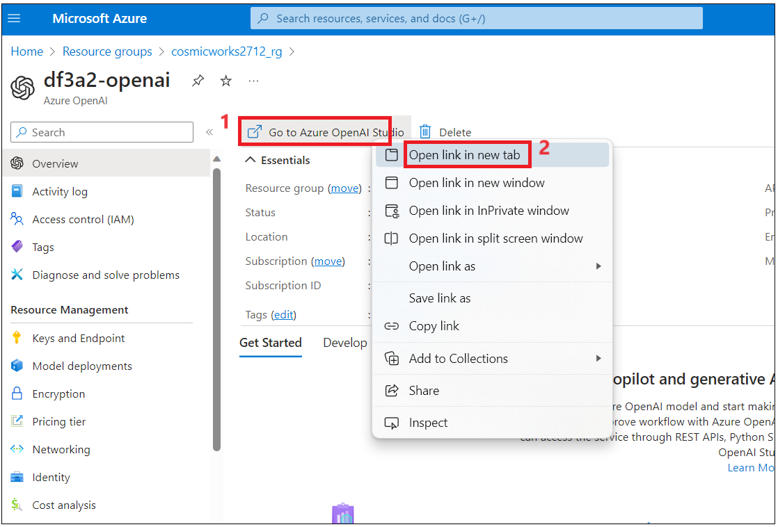

1. **gpt-35-turbo** and **text-embedding-ada-002** models should have been deployed successfully.

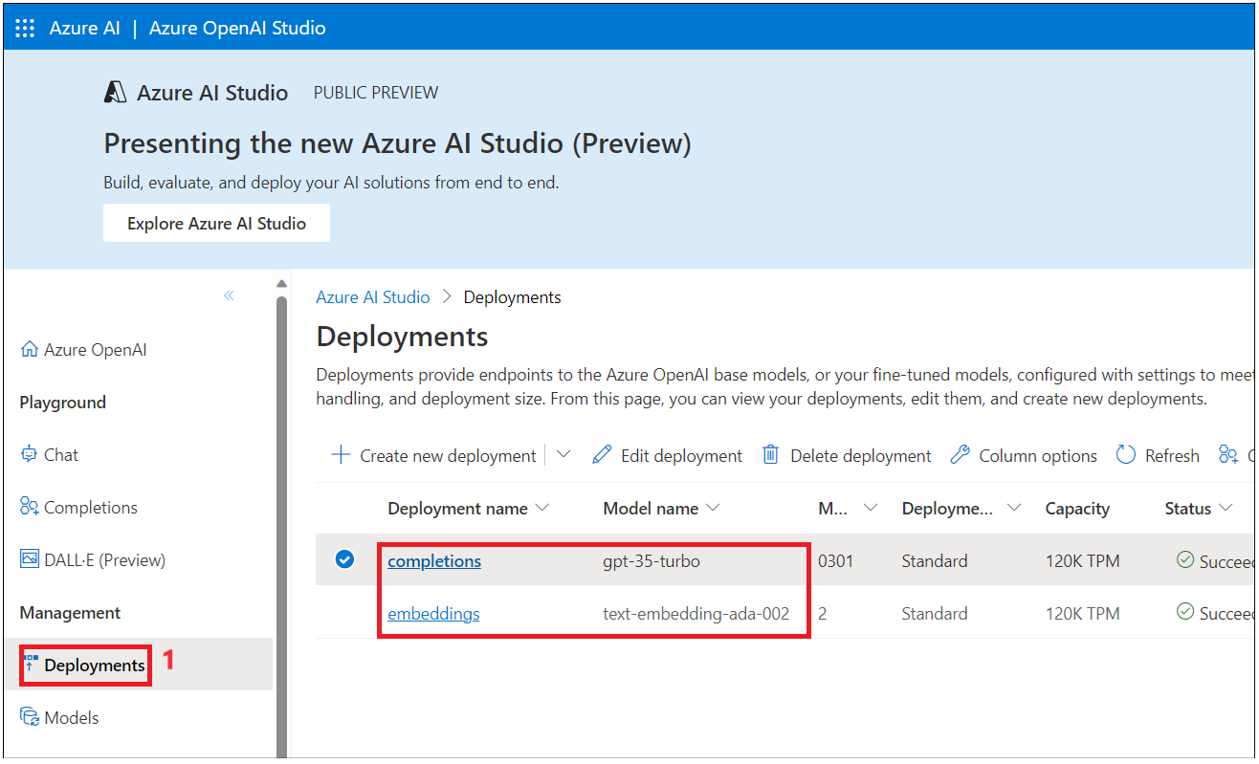

1. Go back to the resource group page and click on **the Storage account** name.

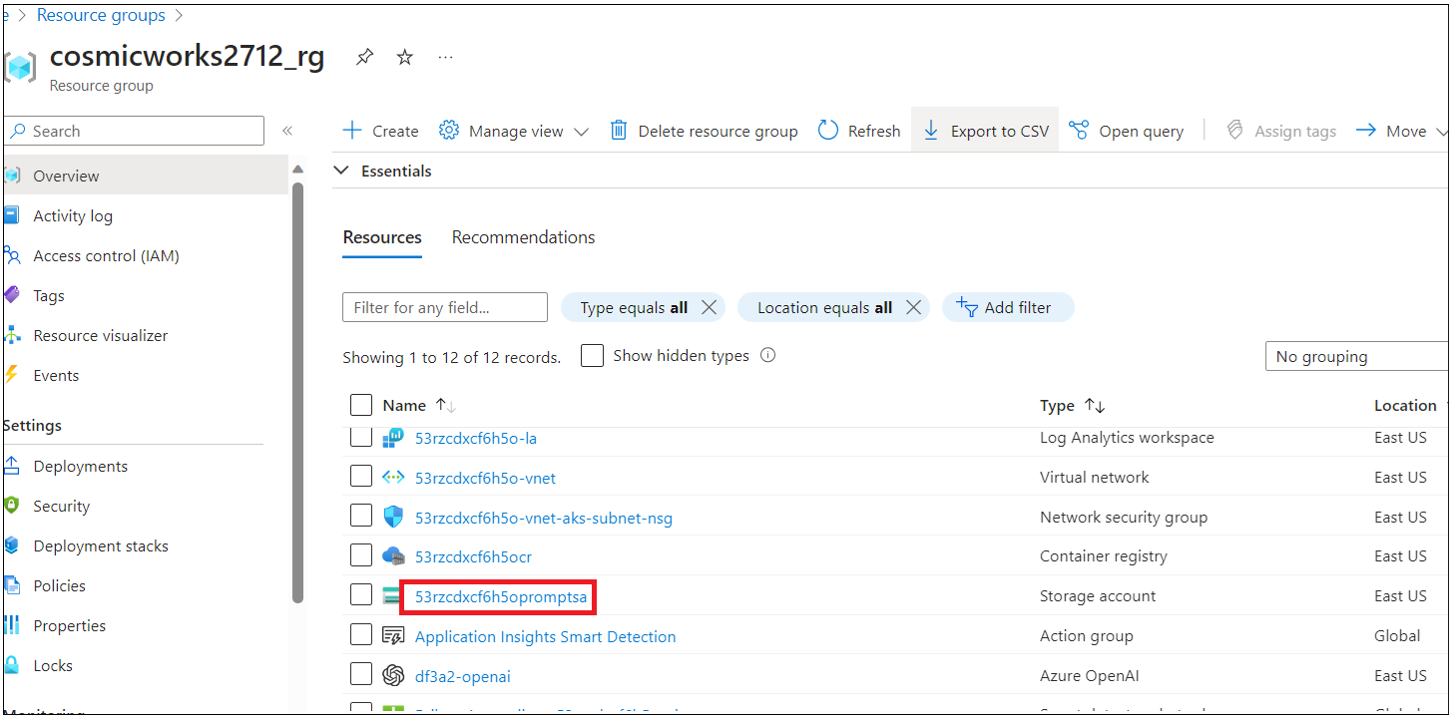

1. From the left navigation menu, click on **Account keys** copy Connections string value and save it notepad to a variable **Blobstorage Connectionstring** and key to a variable **Blobstorage key**

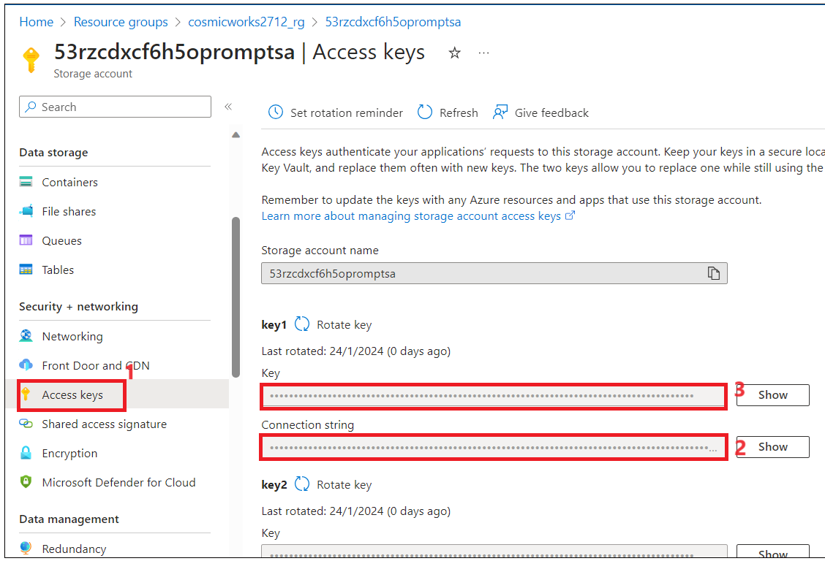

1. Your Notepad should have below values to use in your next task.

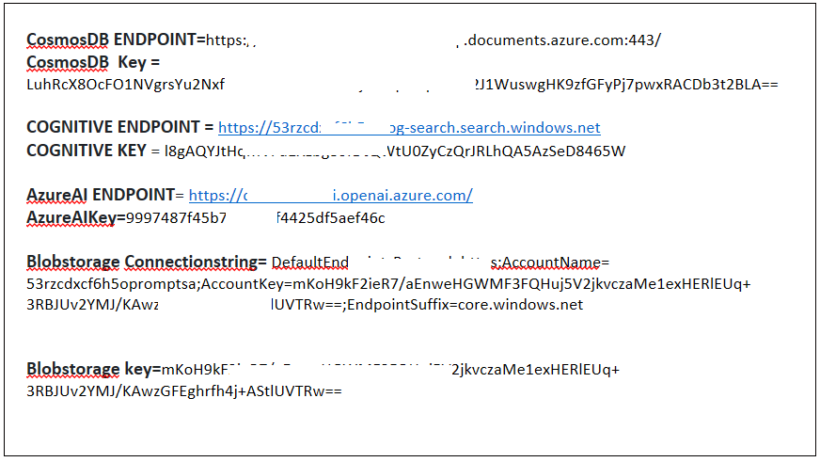

**Task 4: Run the solution locally using Visual Studio**

You can run the website and the REST API that supports it locally. You need to first update your local configuration and then you can run the solution in the debugger using Visual Studio.

1. Open **Visual Studio 2022** from your Desktop or from your Start menu.

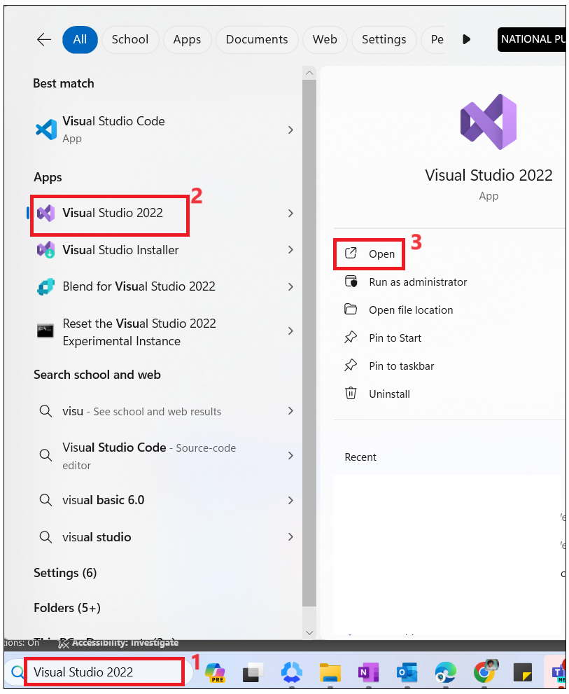

1. Click on **Open a project or solution**.

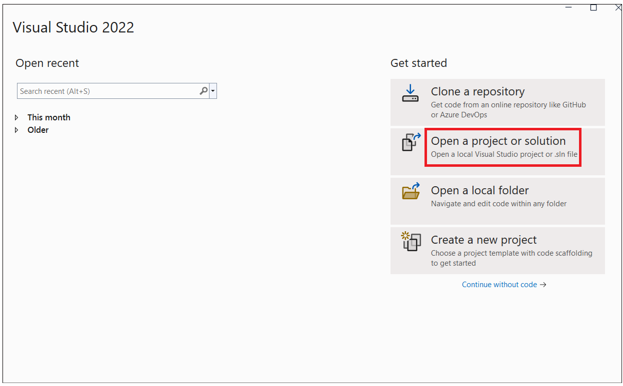

1. Browse to ++C:\Labfiles\starter-artifacts\code\VectorSearchAiAssistant++ and select **VectorSearchAiAssistant-Starter.sln** solution.

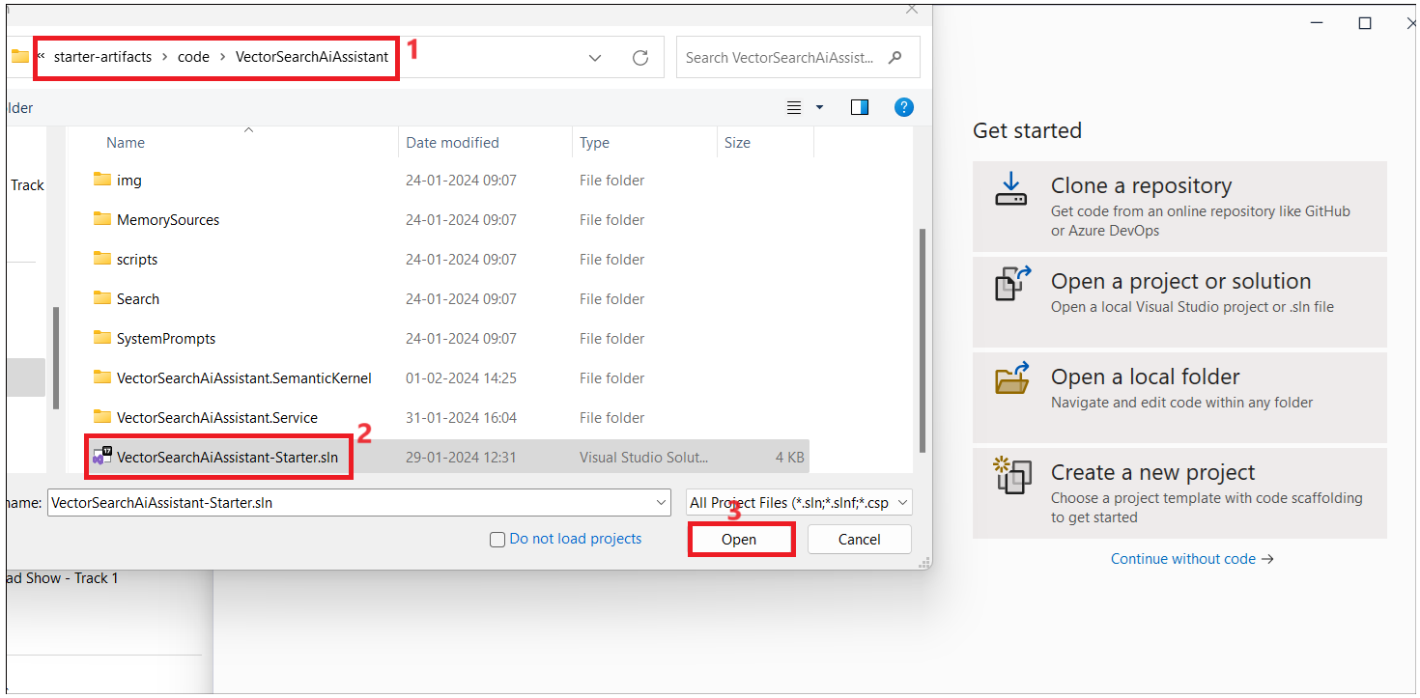

1. Click on **Sign in**.

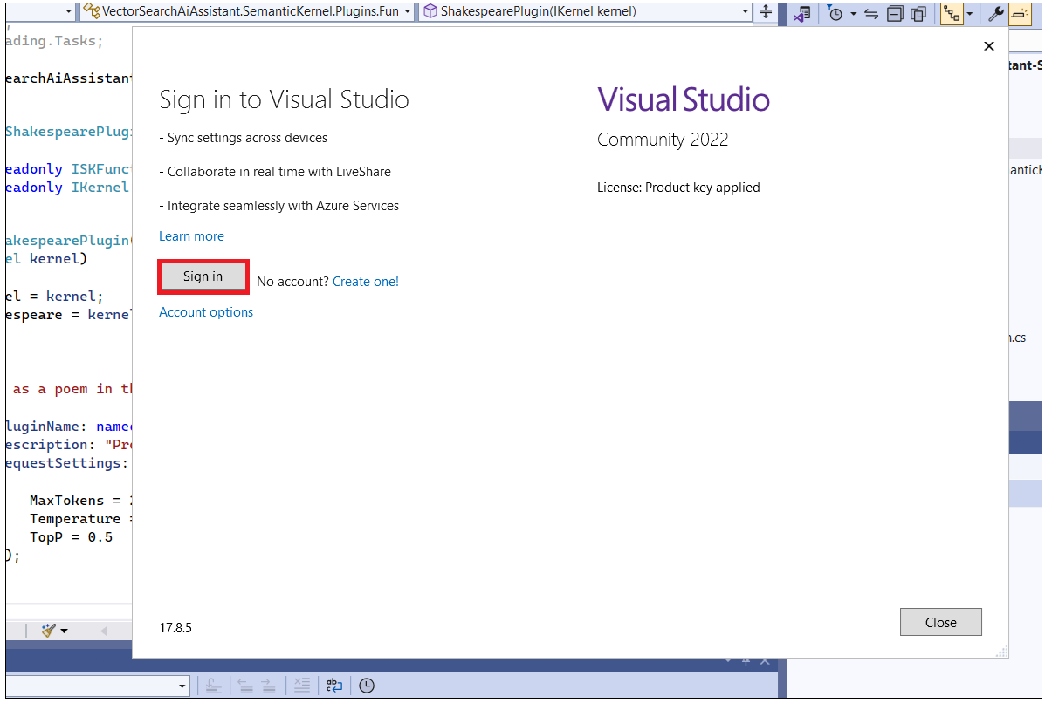

1. Sign in with your Azure subscription and **Configure local settings** as per the below steps.

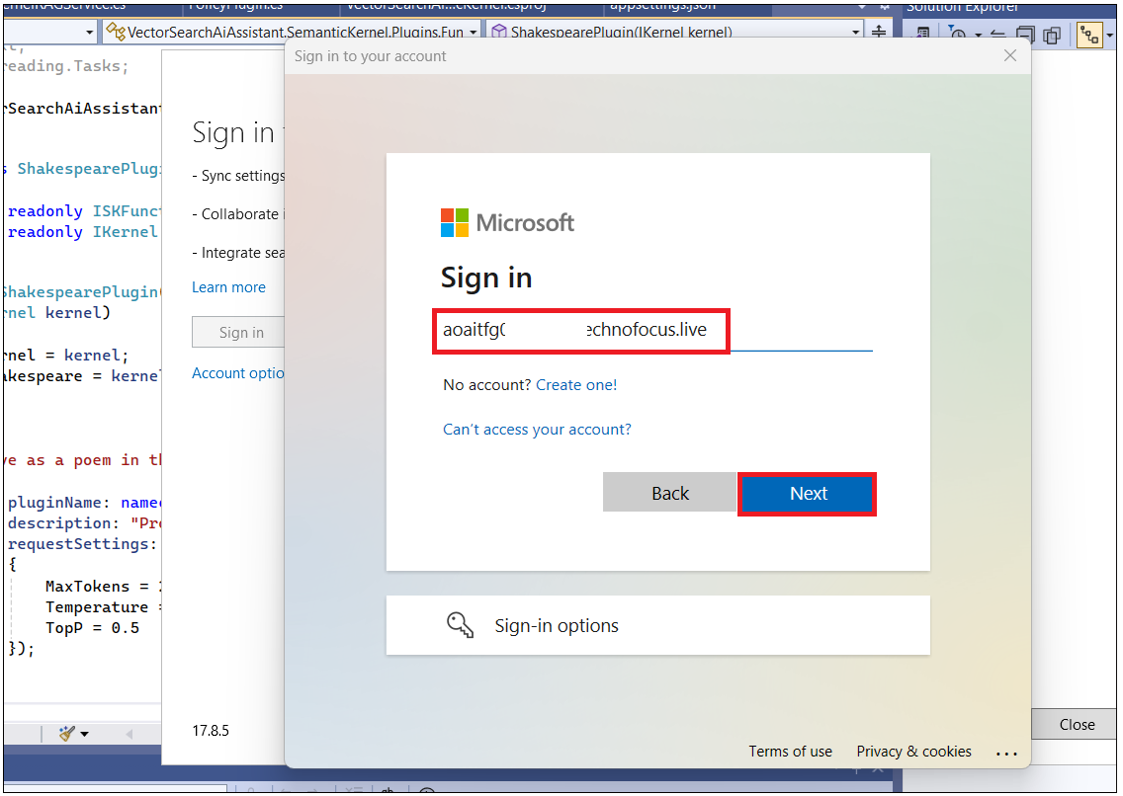

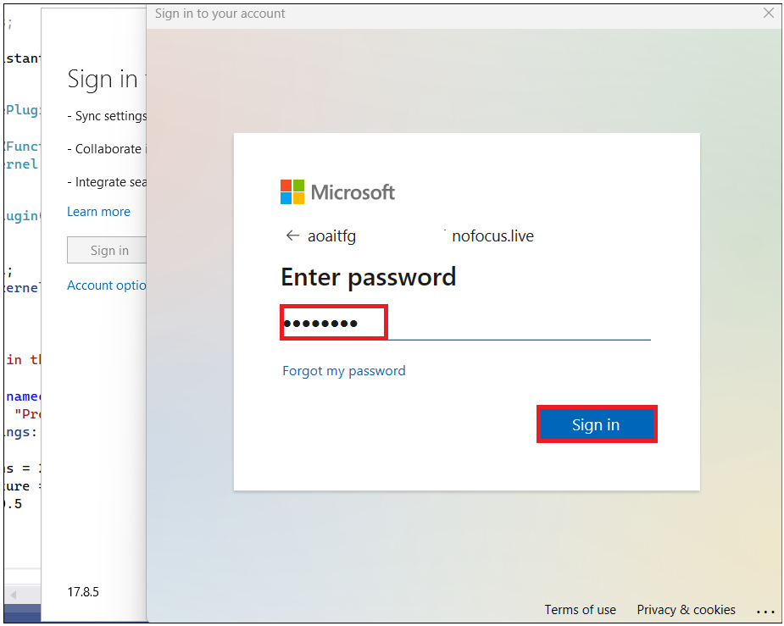

1. **Close** the account details window.

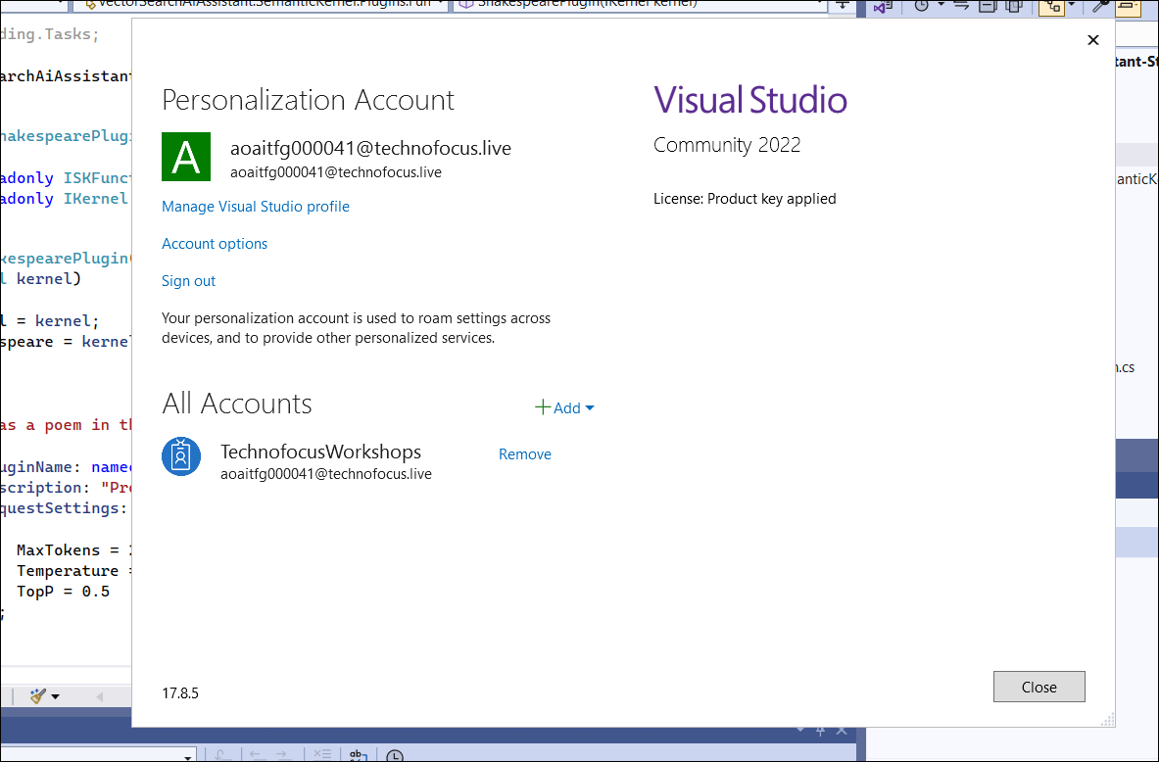

1. In the **ChatServiceWebApi** project, review the content of the **appsettings.json** file.

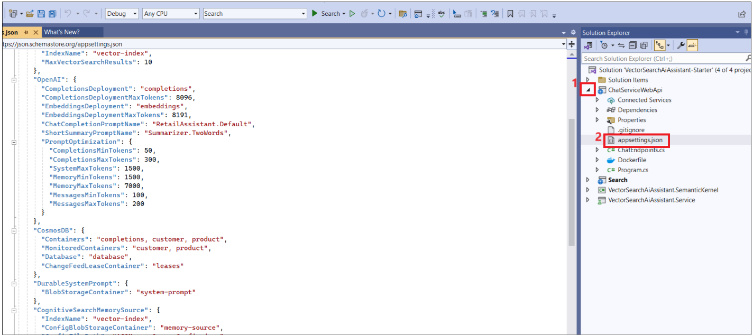

**NOTE**: If you deploy using a pre-existing Azure OpenAI account. You will need to update CompletionsDeployment and EmbeddingsDeployment values to match the names used for these models in your Azure OpenAI account.

{

"Logging": {

"LogLevel": {

"Default": "Information",

"Microsoft.AspNetCore": "Warning",

"Microsoft.SemanticKernel": "Error"

},

"ApplicationInsights": {

"LogLevel": {

"Default": "Information",

"Microsoft.AspNetCore": "Warning",

"Microsoft.SemanticKernel": "Error"

}

}

},

"AllowedHosts": "*",

"MSCosmosDBOpenAI": {

"CognitiveSearch": {

"IndexName": "vector-index",

"MaxVectorSearchResults": 10

},

"OpenAI": {

"CompletionsDeployment": "completions",

"CompletionsDeploymentMaxTokens": 8096,

"EmbeddingsDeployment": "embeddings",

"EmbeddingsDeploymentMaxTokens": 8191,

"ChatCompletionPromptName": "RetailAssistant.Default",

"ShortSummaryPromptName": "Summarizer.TwoWords",

"PromptOptimization": {

"CompletionsMinTokens": 50,

"CompletionsMaxTokens": 300,

"SystemMaxTokens": 1500,

"MemoryMinTokens": 1500,

"MemoryMaxTokens": 7000,

"MessagesMinTokens": 100,

"MessagesMaxTokens": 200

}

},

"CosmosDB": {

"Containers": "completions, customer, product",

"MonitoredContainers": "customer, product",

"Database": "database",

"ChangeFeedLeaseContainer": "leases"

},

"DurableSystemPrompt": {

"BlobStorageContainer": "system-prompt"

},

"CognitiveSearchMemorySource": {

"IndexName": "vector-index",

"ConfigBlobStorageContainer": "memory-source",

"ConfigFilePath": "ACSMemorySourceConfig.json"

},

"BlobStorageMemorySource": {

"ConfigBlobStorageContainer": "memory-source",

"ConfigFilePath": "BlobMemorySourceConfig.json"

}

}

}

1. In the **ChatServiceWebApi** project, right-click and click on **Add- > New** **Item** to create JSON file.

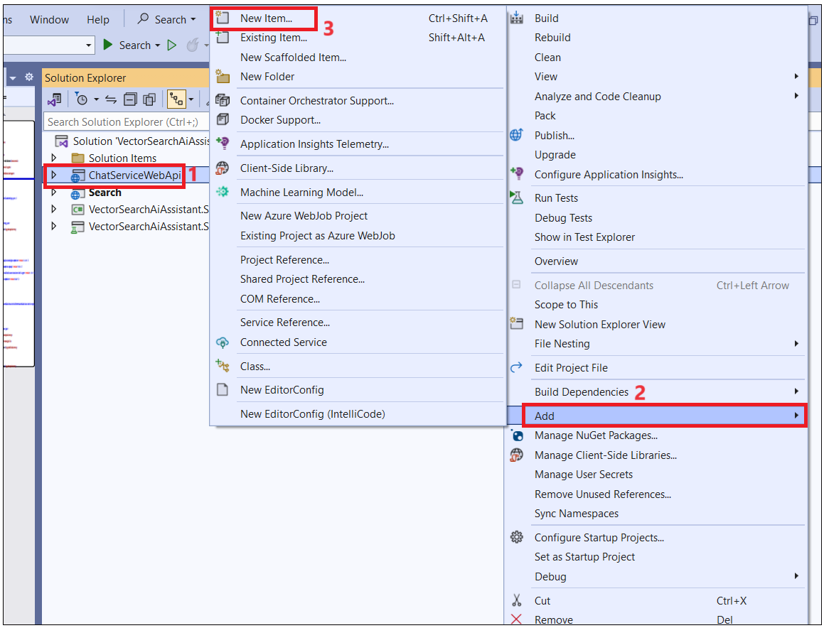

1. Ente the name of the file as **appsettings.Development.json** and then click on **Add**.

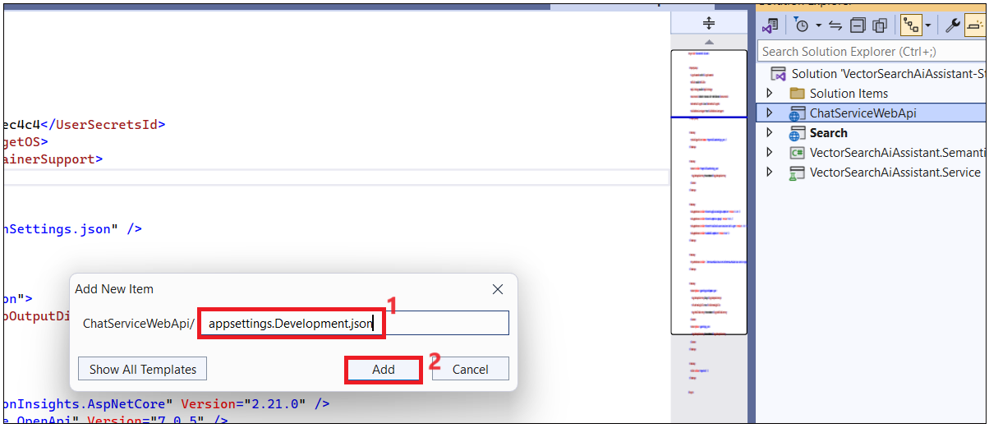

1. Add the below code into the file.

**Note**: You can find **appsettings.Development.json file with code in the C:\Labfiles folder.**

**{**

**"MSCosmosDBOpenAI": {**

**"CognitiveSearch": {**

**"Endpoint": "https://<...>.search.windows.net",**

**"Key": "<...>"**

**},**

**"OpenAI": {**

**"Endpoint": "https://<...>.openai.azure.com/",**

**"Key": "<...>"**

**},**

**"CosmosDB": {**

**"Endpoint": "https://<...>.documents.azure.com:443/",**

**"Key": "<...>"**

**},**

**"DurableSystemPrompt": {**

**"BlobStorageConnection": "<...>"**

**},**

**"BlobStorageMemorySource": {**

**"ConfigBlobStorageConnection": "<...>"**

**},**

**"CognitiveSearchMemorySource": {**

**"Endpoint": "https://<...>.search.windows.net",**

**"Key": "<...>",**

**"ConfigBlobStorageConnection": "<...>"**

**}**

**}**

**}**

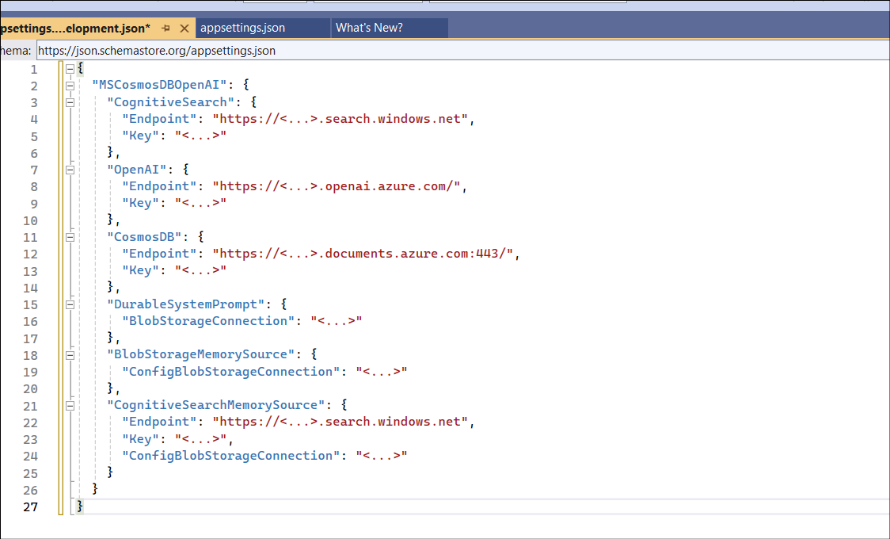

1. **Replace the** below variable values with the **Azure resource** values you have saved in **Notepad** values and **Save** the file.

CognitiveSearch

Endpoint : replace the endpoint with your **COGNITIVESearch ENDPOINT**

Key : replace the endpoint with your **COGNITIVE Search KEY**

OpenAI

Endpoint : replace the endpoint with your **AzureAI ENDPOINT**

Key : replace the endpoint with your **AzureAIKey**

CosmosDB

Endpoint : replace the endpoint with your **CosmosDB ENDPOINT**

Key : replace the endpoint with your **CosmosDB Key**

BlobStorageConnection : **Blobstorage Connectionstring**

CognitiveSearchMemorySource

Endpoint : replace the endpoint with your **COGNITIVESearch ENDPOINT**

Key : replace the endpoint with your **COGNITIVE Search KEY**

ConfigBlobStorageConnection : **Blobstorage Connectionstring**

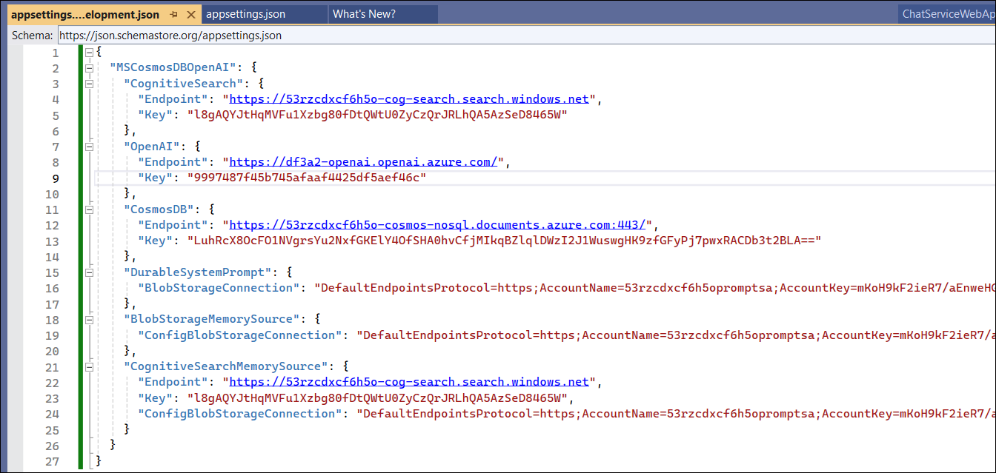

**Task 5: Run and debug solution in Visual Studio.**

Before you can start debugging, you need to set the startup projects. To do this,

1. Right-click on the solution in the Solution Explorer and select **Properties**.

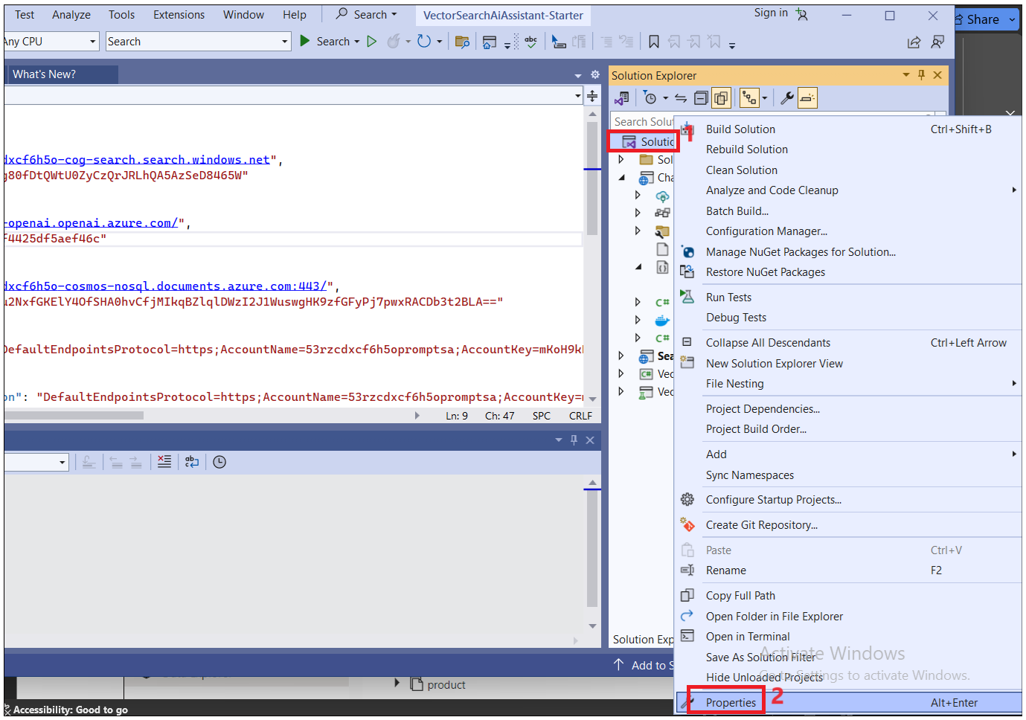

1. Set **Startup Projects.**... In the dialog that opens, select **Multiple startup projects** and set the **Action** for the **ChatServiceWebApi** and **Search** **projects** to **Start**. Click on **Apply -> OK**

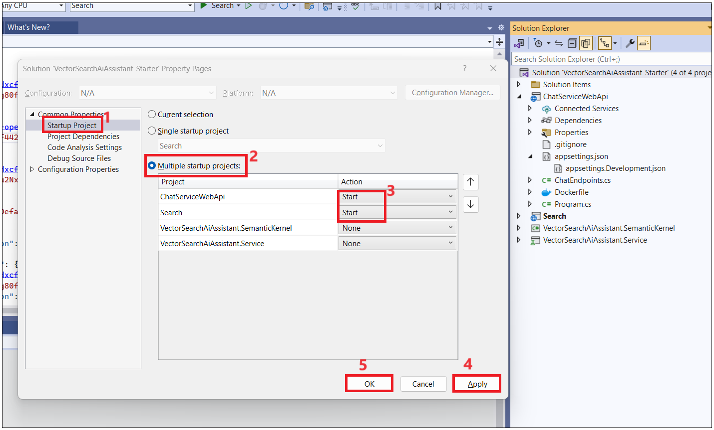

1. Also, make sure the newly created **appsettings.Development.json** file is copied to the output directory. To do this, right-click on the file in the Solution Explorer and select **Properties**.

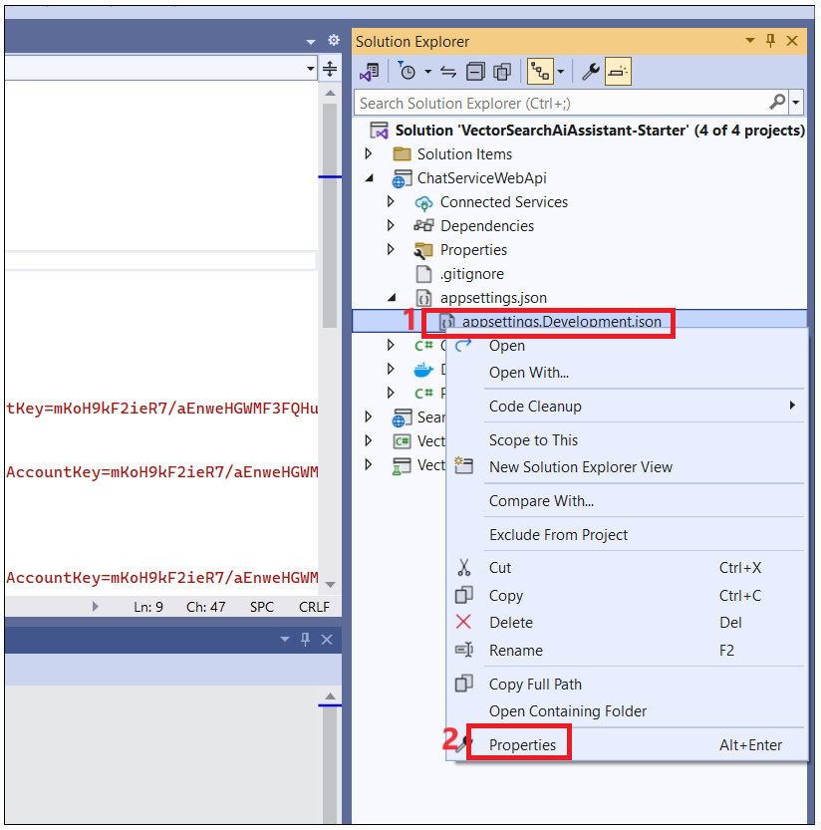

1. In the properties window, set the **Copy to** **Output Directory property** to Copy **always**.

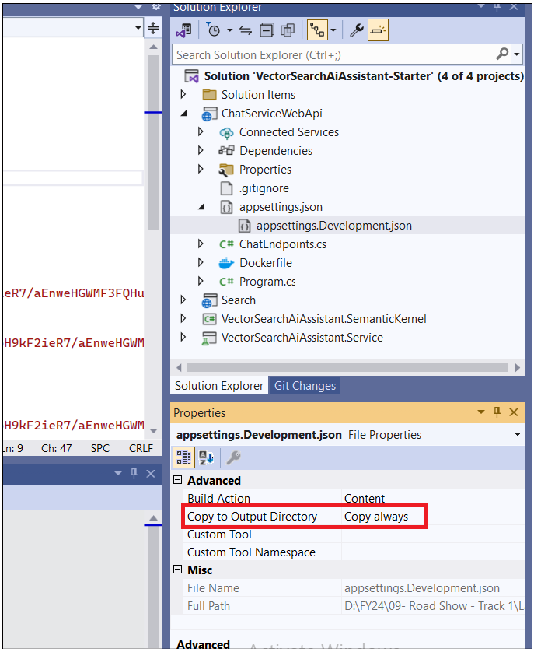

1. You are now ready to start debugging the solution locally. To do this, press F5 or select **Debug > Start Debugging** from the menu.

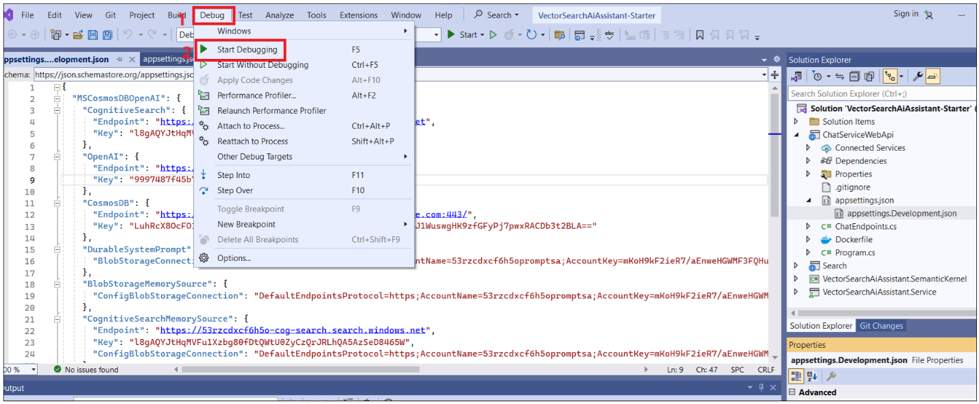

**NOTE**: With Visual Studio, you can also use alternate ways to manage the secrets and configuration. For example, you can use the Manage User Secrets option from the context menu of the ChatWebServiceApi project to open the secrets.json file and add the configuration values there.

1. If it prompts you to install certificate then click on **Yes**.

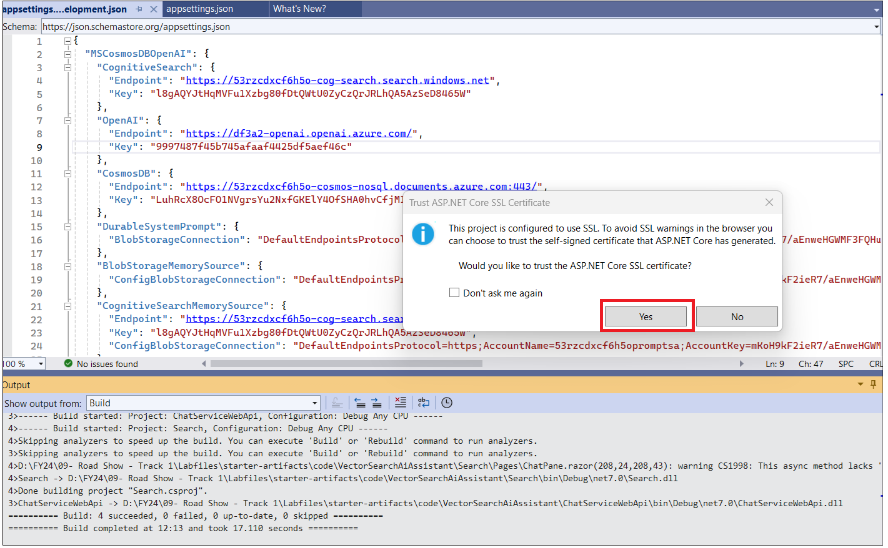

1. Click on **Yes** again.

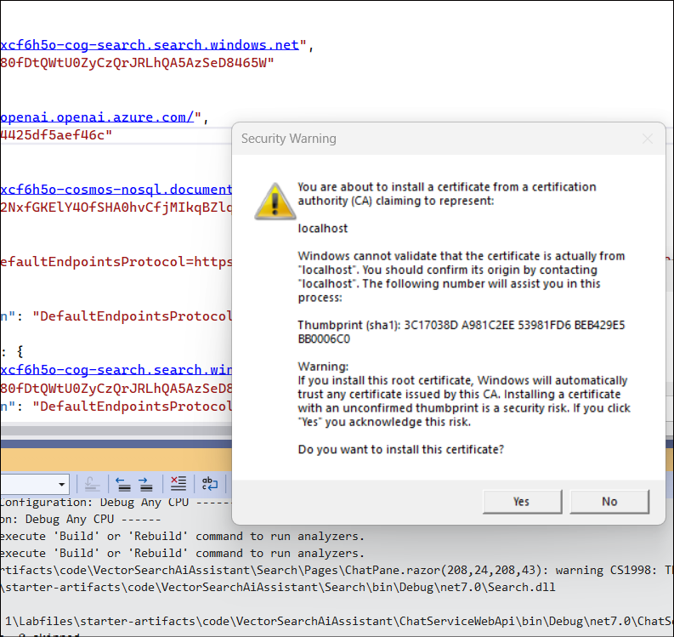

1. **App opens in a default browser.**

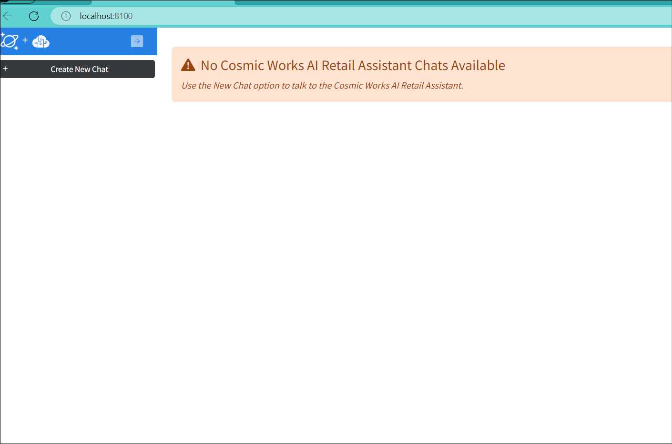

**Summary**

We have learned the below tasks as part of the lab.

• We deployed Azure Cosmos DB with the NoSQL API with database named database and containers named completions with a partition key of /sessionId, customer with a partition key of /customerId, embedding with a partition key of /id, product with a partition key of /categoryId, and leases with a partition key of /id.

• We also deployed Azure OpenAI with the following deployments: o completions with the gpt-35-turbo model o embeddings with the text-embedding-ada-002 model

• We also deployed Azure Cognitive Search, Azure Container Apps, Azure Container Registry and Azure Storage Account.